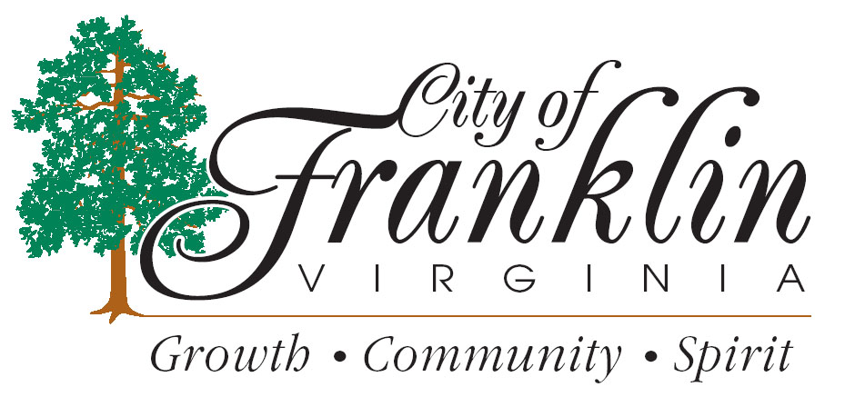FALL Amnesty Week
The City of Franklin Department of Public Works and The Department of Community Development are pleased to announce that they have declared OCTOBER 7-11, 2019, as Fall Amnesty Week. In an effort to assist City residents in a major fall cleaning, these days are set aside by the City to allow resident owners and tenants (current city of Franklin trash customers only) a temporary pardon to rid properties of unsightly accumulations of trash, junk and debris without cost to residents for pickup and removal.

The following items may be placed at the curb for pickup on October 7,8,9,10 and 11 ON YOUR REGULAR TRASH DAY. .
- Unused objects from your home such as appliances, furniture, TV’s, etc.
- Unused deteriorated building materials and firewood.

Any items placed at curbside should be left in neat piles adjacent to the street. Please be mindful of obstructions when placing those items to allow for safe collection by our crews. Obstructions can be parked vehicles, power poles, overhead utility lines, mailboxes, fire hydrants, signs, trees or hedges, or any fixed object that interferes with the safe collection of the items placed at curbside.

Caution: No demolition debris, trees over 6’’ in diameter, lot-clearing materials, paint or other hazardous materials will be collected. Limbs must be cut to ordinance lengths (4’ long) and piled neatly at curbside. Please call 757-562-8564, if you are in doubt about any items before placing them at the curb.

Items not available for pickup by the City, may be carried to the SPSA Transfer Station on Route 671 (General Thomas Hwy) Phone Number is 757-420-4700 ext 527.

For further information contact Franklin Public Works at 757-562-8564
Spring Amnesty Week
April 6-10, 2020

