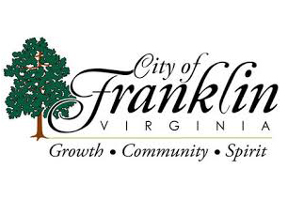

Human Resources Administrative Assistant

The Human Resources Administration Assistant will perform administrative and technical duties for the City of Franklin.

Responsibilities will include but are not limited to:

Manages telephone and walk-in requests and questions. Assist with new hire onboarding including the recruitment and selection process. Prepares and maintains, and confidential human resource (HR) files. Completes Form I-9, verifies I-9 documentation and maintains I-9 files. Completes reference and background checks. Provides data entry assistance. Assists employees and supervisors with basic interpretation of HR policies/procedures/benefits and responds to requests or questions. Assists or prepares correspondence and communication initiatives as requested. Responsible for employee mailings.

Requirements:

High school diploma or equivalent. Demonstrated experience with Microsoft Office (Word, Excel, Outlook, etc.). Must have excellent interpersonal skills, the ability to stay organized, demonstrated accuracy with strong attention to details and follow through skills. Demonstrated ability to work with and maintain sensitive and confidential information. Ability to establish and maintain effective working relationships with city officials, other employees, representatives from other public or private agencies, and the general public. Skill communicating effectively both orally and in writing. Demonstrated ability to problem-solve and work effectively and efficiently under pressure.

Preferences:
Some clerical experience. Experience working in a human resources environment. Graduation from an accredited college or university with coursework in business, human resources, or related field, or equivalent applicable experience or training.

Interested candidates should visit www.franklinva.com or obtain a city application during regular business hours at the Human Resources Office located in Franklin City Hall, 207 W. 2nd Ave. Franklin, VA 23851; 757-562-8508. Franklin is an Equal Opportunity Employer.

