Custodial Worker | - City of Franklin
Job description and Requirements:  This job participates in a variety of custodial duties including, but not limited to: operating and buffing machinery, removing trash and cleaning trash bins, cleaning restrooms, mopping and sweeping floors, vacuuming carpets, waxing floors, cleaning windows, dusting offices, delivering mail, and performing other duties as assigned. Required to have knowledge on the tools and techniques used in cleaning the municipal buildings, know about the cleaning chemicals and equipment, have skills in the use of job related tools, equipment, and materials, and have skills in oral and written communication. Position open for both Public Works and City Hall. Salary DOQ + benefits. Part time position.  For more information and details about the job use the contact information on the right! Full job description and details found in the link below the add on the webpage. This job is open until filled! | 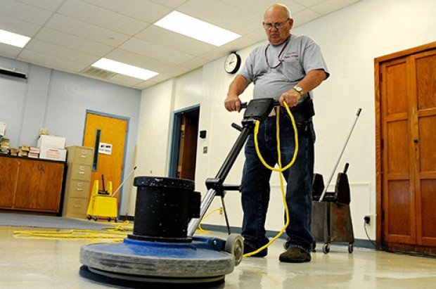  Contact Info  Telephone: (757)562-8508 OR (757)562-8562  Office: 207 West 2nd Avenue Franklin, VA 23851  Email: info@franklinva.com

