Motor Equipment Operator/ Construction Maintenance Worker | - City of Franklin
Job Description and Requirements:  Salary DOQ + benefits. Must be high school graduate or equivalent with experience in road constructions, concrete construction, asphalt installation and drainage construction. Applicant must have a CDL Class A, have truck driving experience as well as heavy construction experience operating heavy equipment.  For a full job description and details use the contact information on the right! This job is open until filled! | 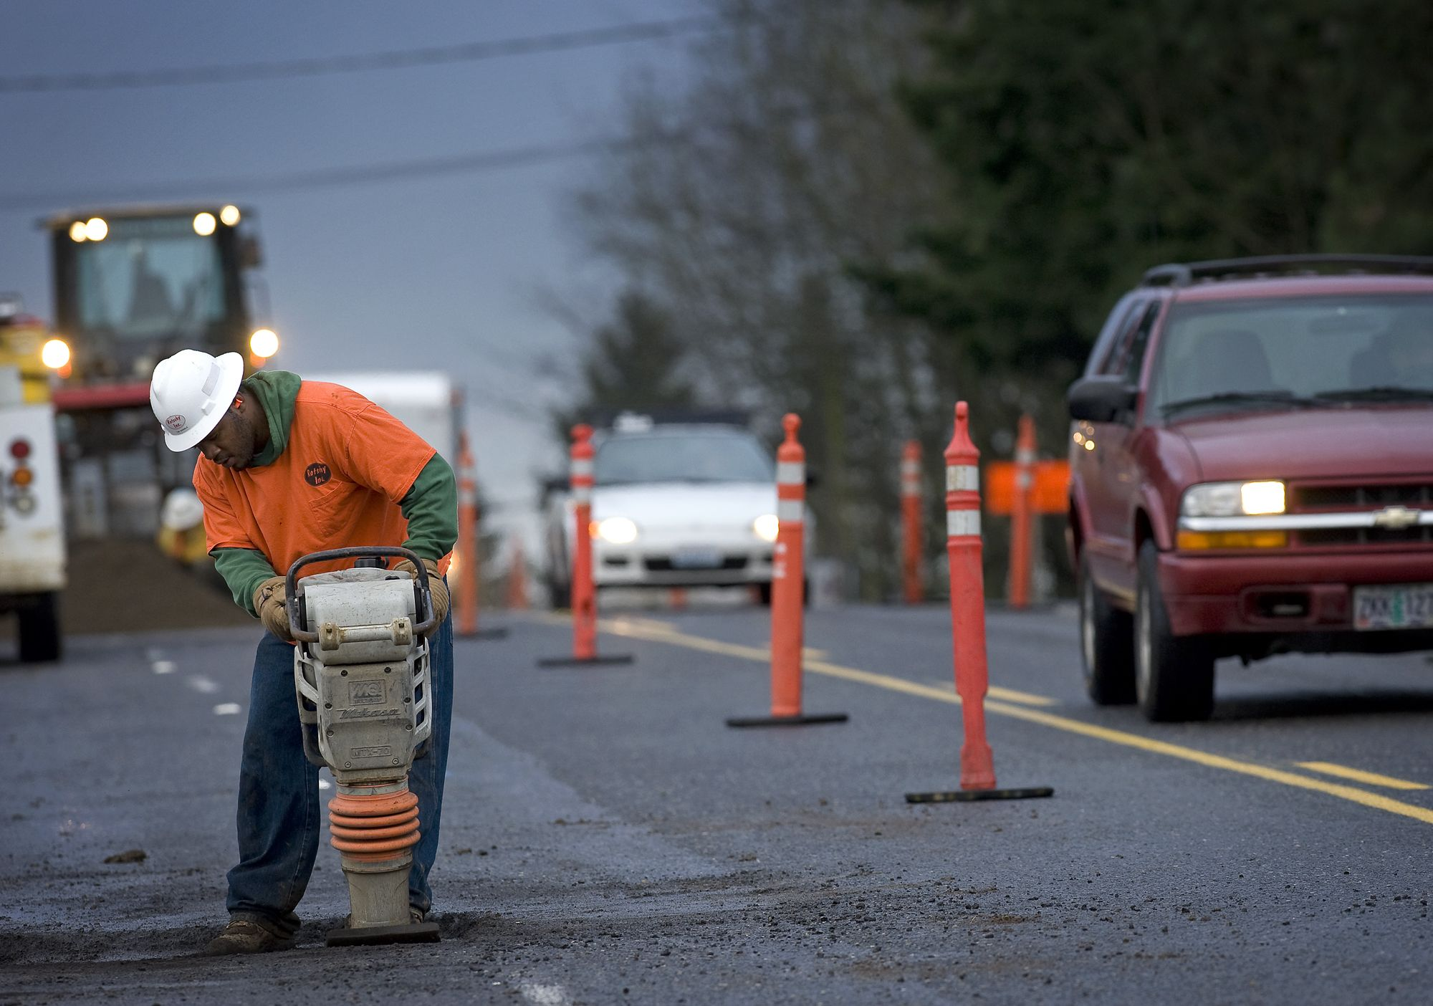  Contact Info  Telephone: (757) 562-8562  Office: 207 West Second Avenue Franklin, VA 23851
