Grounds Maintenance Worker | - City of franklin
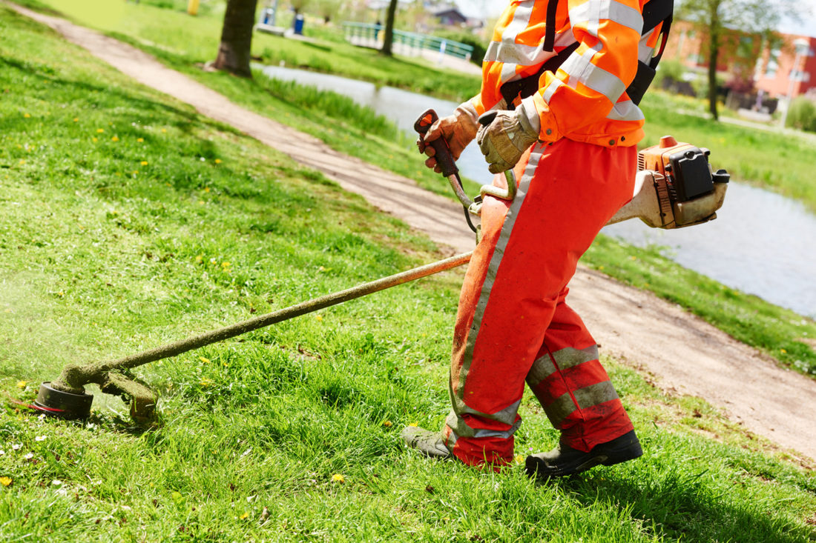  Job Description and Requirements  This job participates in a variety of grounds maintenance assignments. These include, but are not limited to: maintaining road side rights-of-way, cemeteries, and other city properties; mowing grass and hedges; raking leaves; removing trees; clearing ditches; cleaning sidewalks and curbs, etc. Required to have knowledge of grounds maintenance procedures and equipment, knowledge of the use of hand and power tools, knowledge of the safe use, operation, and maintenance of equipment, skill in the use of ground maintenance equipment, and skill in maintenance of assigned equipment. Applicant must have high school diploma or equivalent and a valid Virginia driver’s license (CDL preferred). Salary DOQ plus benefits. | 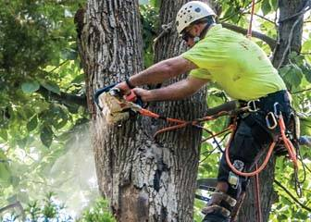  Contact Info  Telephone: (757)562-8562  Office: 207 West Second Avenue Franklin, VA 23851  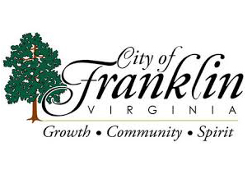
For more details and information on the job, use the
contact information on the right! This job is open until filled!

