Second Class Line Technician | - City of Franklin
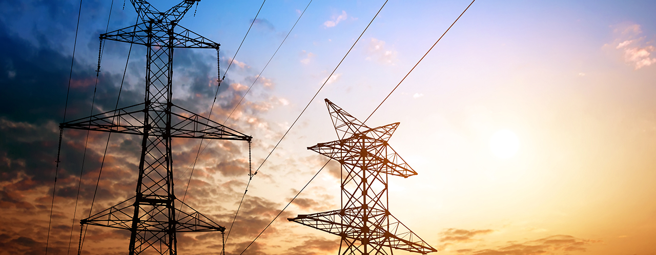  Job Description and Requirements:  This job performs technical work assisting in the installation, maintenance, and repair of the electric distribution system. Some of the major duties for this job include, but are not limited to: climbing poles, assisting in the installation, maintenance, and repair of low and high voltage transmission and distribution lines, terminating high-voltage wires, keeping line trucks supplied with tools and materials, installing secondary cable, trim trees from lines, etc. The minimum qualifications for this job are: completion of specialized training in the field work, basic skills typically associated with high school education, one to three years of experience or service, and possession or ability to obtain a State of Virginia driver’s license. Salary DOQ plus excellent benefits.  For more information and details about the job use the contact information on the right! This job is open until filled! | 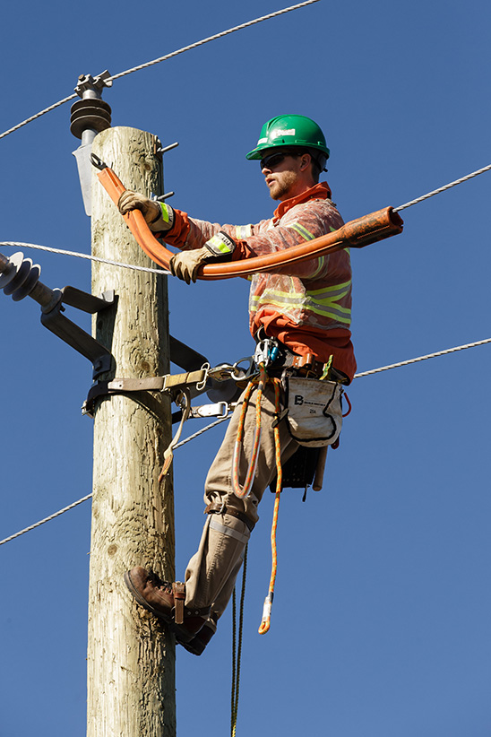  Contact Info  Telephone: (757)562-8566  Office: 207 West 2nd Avenue Franklin, VA 23851  