Apprentice Line Technician | - City of Franklin
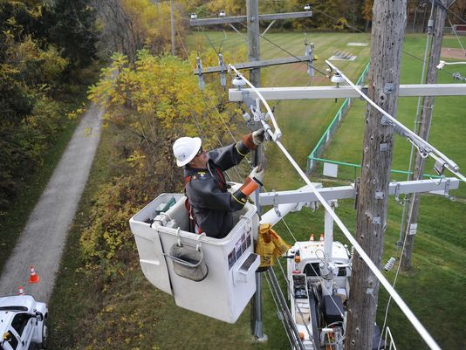  Job Description and Requirements:  This is a trainee position which performs technical work assisting in the installation, maintenance, and repair of the electric distribution system. Some of the major duties for this job include, but are not limited to: replacing malfunctioning equipment and tools, reconnecting lines and fasten guy wires, climb poles and operate a bucket truck, assist in the installation, repair, and maintenance of underground and overhead electrical services, clean right of way areas, etc. The minimum qualifications for this job include: the ability to read, write, and perform mathematical calculations (high school completion or equivalent), completion of an internship/ apprenticeship or having a similar position for one to two years, and the possession or ability to obtain a State of Virginia driver’s license.  For more details and information about the job use the contact information on the right! This job is open until filled! | 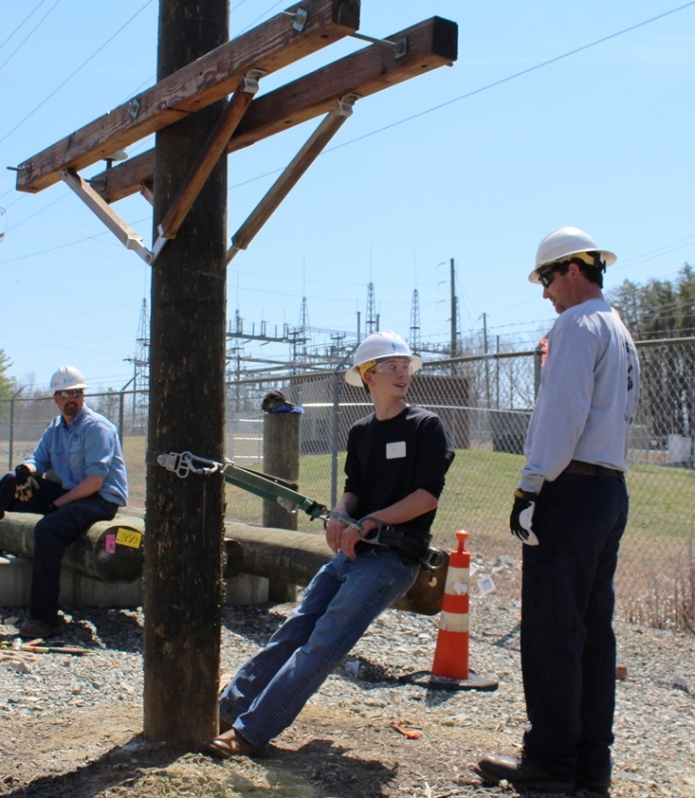  Contact Info  Telephone: (757)562-8566  Office: 207 West 2nd Avenue Franklin, VA 23851  