First Class Line Technician | - City of Franklin
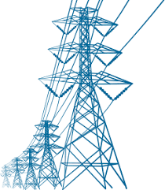  Job Description and Requirements:  This job performs technical work in the installation, maintenance, and repair of the electric distribution system. Some of the major duties for this job include, but are not limited to: climbing poles, assembling and fastening cross-arms on erection poles, use hot-line equipment poles, replacing malfunctioning equipment on poles, installing transformers and other auxiliary equipment, etc. The minimum qualifications for this job include basic skills associated with a high school education, one to three years of experience, and the possession of or ability to obtain a State of Virginia driver’s license. Salary DOQ plus excellent benefits.  For more information and details about the job use the contact information on the right! This job is open until filled! | 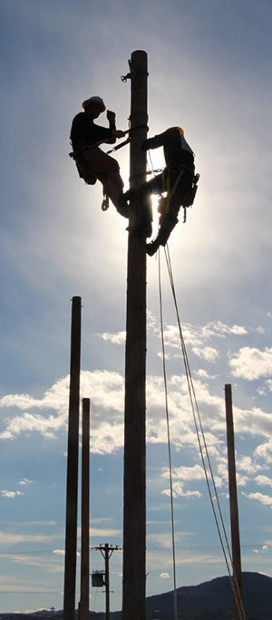  Contact Info  Telephone: (757)562-8566  Office: 207 West 2nd Avenue Franklin, VA 23851  