CITY CLIPS
February 2019

www.franklinva.com
IMPORTANT DATES TO REMEMBER:

Recycling Dates – Feb. 7th, 8th, 21st, 22nd
(All meetings below are held in Council Chambers at City Hall)
City Council Meetings – Feb. 11th & 25th
School Board Meetings – Feb. 21st
Planning Commission Meeting – Feb. 28th

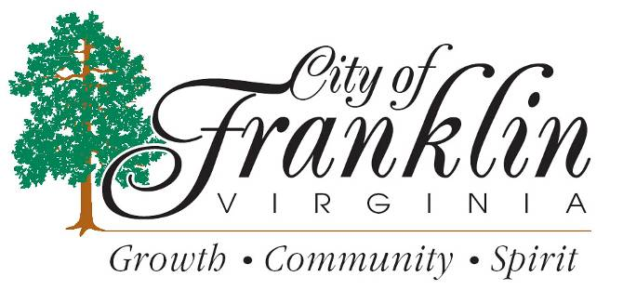

HOLIDAY TRASH PICK UP

City Offices will be closed Monday, February, 18, 2019, George Washington Day. Trash WILL run Regular Routes.

2019 Business Personal Property Forms have been mailed and should be returned to the Commissioner of the Revenue’s Office by February 15, 2019 to avoid a penalty for failure to file. If you have any questions or need assistance, please call Lynn Beale at 562-8783 or email her at lbeale@franklinva.com.

2019 City Business License Applications have been mailed and are due March 1, 2019 with payment. If you have any questions, please call Marcy Wiggins at 562-8547 in the Commissioner of the Revenue’s Office.

State Income Tax Forms for 2018 are being printed and were delayed due to the federal tax reform. The Commissioner of the Revenue’s Office will have a limited number of forms and instructions available in a few weeks.

For FCPS SPORTS SCHEDULES, please visit:http://www.tririversdistrictva.org/g5-bin/client.cgi?G5genie=302&school_id=4

