CITY CLIPS
November 2018

www.franklinva.com
IMPORTANT DATES TO REMEMBER:

Recycling Dates – Nov. 1^{st,} 2^{nd,} 15^{h}, 16th, 29th, & 30th
(All meetings below are held in Council Chambers at City Hall
City Council Meetings – Nov. 26th
School Board Meetings – Nov. 15th
Planning Commission Meeting – Nov. 22nd

Message from the City Treasurer:

The Real Estate and Personal Property Tax bills for 2018 have been mailed. If you have not received your bill(s) by October 5th, please stop by the Treasurer’s office and we will check into this for you.
Please Note that the Due Date for these bills is December 05, 2018. To void additional penalties the payment MUST be received on or before December 05, 2018. The office will accept a post mark of December 05, 2018.

If you received a personal property bill, but no longer live in the City of Franklin or own the vehicle, please call the office at 757-562-8540.

Should you own a PET (DOG and or CAT), Please remember that all pets must be licensed each year. Please call the office for additional information.

If you would like to purchase an EZ-Pass, please stop by the Treasurer’s office. We have both the Regular EZ-Pass and the Flex EZ-Pass. This is the easiest way to travel through tunnels and toll roads. For more information, call the Treasurer’s office at 757-562-8540 or stop by the office.

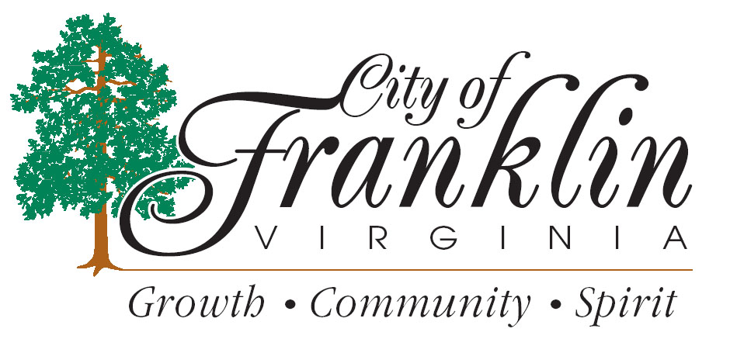

HOLIDAY TRASH PICK UP

The City of Franklin WILL have regular Monday’s trash pickup for Veterans Day, November 12, 2018. The Public Works office will be closed and reopen Tuesday, November 13, 2018.

The City of Franklin WILL NOT have regular trash pickup on Thanksgiving Day, November 22, 2018. Thursday’s and Friday’s Routes WILL BE picked up on Friday, November 23, 2018. The City of Franklin Public Works Offices will close at 11:30am on Wednesday, November 21, 2018 and reopen Monday, November 26, 2018 @ 7:30am

For FCPS SPORTS SCHEDULES, please visit:http://www.tririversdistrictva.org/g5-bin/client.cgi?G5genie=302&school_id=4

