CITY CLIPS
October 2018

www.franklinva.com
IMPORTANT DATES TO REMEMBER:

Recycling Dates – Oct. 4^{th,} 5th, 18th, 19th
(All meetings below are held in Council Chambers at City Hall
City Council Meetings – Oct. 8th & 22nd
School Board Meetings – Oct. 18th
Planning Commission Meeting – Oct. 25th

Our offices will be closed Oct. 8th in observance of Columbus Day, but trash will be picked up as scheduled.

Here at the Public Works Department, we’re asking for donations again for our Thanksgiving dinners this season, for all those who helped last year, please know it was very much appreciated; so let’s help some more families this year. An ad was issued in the Tidewater News, July 25th, with all the details and I have also sent out a mass email to all the City of Franklin departments.
Thank you,

Orange Greene, Store’s Clerk
Public Works Department
757-562-8567

Message from the City Treasurer:

The Real Estate and Personal Property Tax bills for 2018 have been mailed. If you have not received your bill(s) by October 5th, please stop by the Treasurer’s office and we will check into this for you.
Please Note that the Due Date for these bills is December 05, 2018. To void additional penalties the payment MUST be received on or before December 05, 2018. The office will accept a post mark of December 05, 2018.

If you received a personal property bill, but no longer live in the City of Franklin or own the vehicle, please call the office at 757-562-8540.

Should you own a PET (DOG and or CAT), Please remember that all pets must be licensed each year. Please call the office for additional information.

If you would like to purchase an EZ-Pass, please stop by the Treasurer’s office. We have both the Regular EZ-Pass and the Flex EZ-Pass. This is the easiest way to travel through tunnels and toll roads. For more information, call the Treasurer’s office at 757-562-8540 or stop by the office.

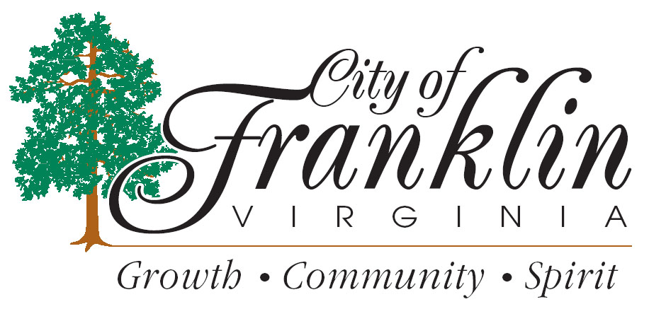

FALL Amnesty Week
The City of Franklin Department of Public Works and The Department of Community Development are pleased to announce that they have declared October 1-5, 2018, as Fall Amnesty Week. In an effort to assist City residents in a major fall cleaning, these days are set aside by the City to allow resident owners and tenants (current city of Franklin trash customers only) a temporary pardon to rid properties of unsightly accumulations of trash, junk and debris without cost to residents for pickup and removal.

The following items may be placed at the curb for pickup on October 1 2,3,4, and 5 ON YOUR REGULAR TRASH DAY.

- Unused objects from your yard such as lawnmowers, containers, old tires, etc.
- Unused objects from your home such as appliances, furniture, TV’s, etc.
- Unused deteriorated building materials and firewood.

Any items placed at curbside should be left in neat piles adjacent to the street. Please be mindful of obstructions when placing those items to allow for safe collection by our crews. Obstructions can be parked vehicles, power poles, overhead utility lines, mailboxes, fire hydrants, signs, trees or hedges, or any fixed object that interferes with the safe collection of the items placed at curbside.

Caution: No demolition debris, trees over 6’’ in diameter, lot-clearing materials, paint or other hazardous materials will be collected. Limbs must be cut to ordinance lengths (4’ long) and piled neatly at curbside. Please call 757-562-8564, if you are in doubt about any items before placing them at the curb.

Items not available for pickup by the City, may be carried to the SPSA Transfer Station on Route 671 (General Thomas Hwy) Phone Number is 757-420-4700 ext. 527.

For further information contact Franklin Public Works at 757-562-8564
SPRING Amnesty Week
April 1-5, 2019
For FCPS SPORTS SCHEDULES, please visit:http://www.tririversdistrictva.org/g5-bin/client.cgi?G5genie=302&school_id=4

