DEPARTMENT OF COMMUNITY DEVELOPMENT

ZONING CLEARANCE APPLICATION
SWIMMING POOLS AND SPAS

FEE: ___$25.00____ DATE: _______________________

APPLICANT NAME: _________________________________________________________________________________

CITY OF FRANKLIN:

ADDRESS: ____________________________________________________________________________________________

PHONE (HOME): _____________________________ (BUSINESS):______________________________________________

EMAIL ADDRESS: _____________________________________________________________________________________

PROPERTY ADDRESS: __________________________________________________ ZONED: ______________________

OWNER (If other than applicant) : _________________________________________________PHONE:__________________

OWNER ADDRESS: ____________________________________________________________________________________

DESCRIBE PROPOSED USE: (also attach site plan ) ____________________________________________________________

HEALTH DEPARTMENT APPROVAL NEEDED: YES NO If located in the City

SITE PLAN REQUIRED: YES: NO: Show location of pool/spa with distances from property lines and buildings

FLOOR PLAN LAYOUT: YES: NO:

IS PROPERTY LOCATED IN THE SPECIAL FLOOD HAZARD AREA? (100 year flood plain) YES: NO:

THE APPLICANT/OWNER IS RESPONSIBLE FOR OBTAINING ALL APPLICABLE STATE AND/OR FEDERAL PERMITS REGULATING THE USE OF THE PROPERTY. IT IS UNDERSTOOD THAT NO CHANGE IN USE SHALL BE MADE WITHOUT THE APPROVAL OF THE ZONING ADMINISTRATOR.

SIGNED: _____________________________________________________________DATE____________________________
APPLICANT
-----------------------------------------------------------------------------------------------------------------------------------------------------------
OFFICE USE ONLY

APPROVED: CONDITIONAL APPROVAL: DENIED: REASON FOR DENIAL: _________________________

________________________________________________________________________________________________________

CONDITIONS: __________________________________________________________________________________________

________________________________________________________________________________________________________

SIGNED: _____________________________________________________________DATE:_____________________________
ZONING OFFICER
FRANKLIN DEPARTMENT OF COMMUNITY DEVELOPMENT
207 WEST SECOND AVENUE, FRANKLIN VIRGINIA 23851
OFFICE: 757-562-8580 FAX: 757-562-0870

ALL SECTIONS MUST BE COMPLETED
Franklin Building Permit Application
207 West 2nd Avenue, Franklin, VA 23851, Phone (757)562-8580
Must be accompanied with required construction documents from the list on page two.
A permit is hereby requested for the construction, alteration, repair or demolition of a structure located at:
Address___________________________________________ Tax Map Number__________________

Total Contract Amount, including labor and materials $________________________________________
Check all that apply: Building __ ___Electrical _______Plumbing _______Mechanical _______Other ______

All contractors must submit a copy of their current Virginia Contractor’s License at the time of application.
Contractor’s/Tradesman License Number: ________________________ Class _____ Type ____________

Special Zoning Approval Letter from: Boykins__ Branchville__ Capron__ Courtland__ Ivor__ Newsoms__ Copy of VDOT Driveway Permit , if applicable - Yes___ No___ (Check the appropriate spaces)

Name, Address, Phone Number, Email Address of Contractor: ______________________________________ ___________________________ ____________________________________________________________

Name, Address, Phone Number, Email Address of Property Owner: __________________________________ ________________________________________________________________________________________

Structure is: New___ Existing___ Addition___ Located in the Enterprise Zone _____ Yes ____ No Residential___ Commercial___ Industrial___ HUD Home___ Modular___ Other_______

Lien Agent Name, Address, Phone Number_____________________________________________________
________________________________________________________________________________________
Is property located in the Special Flood Hazard Area? (100 yr. floodplain) ______ Yes _______ No

General Description of Work:_________________________________________________________________
________________________________________________________________________________________
________________________________________________________________________________________
This construction to comply with 2012 ______ (check one) VBC_____ VRC_____ HUD_____

The structure / addition listed herein may not be occupied until such time as the Final Inspection has been passed and/or the Certificate of Occupancy has been issued by this office.
Check one: Owner: ____ Owner Agent: ____ Contractor: ____

Signature_____________________________________________________ Date___________________

FOR OFFICE USE ONLY: Application received by: ______________ Date: ___________
Revised - February 12, 2016 by DEG
Added EZ checkoff & floodplain checkoff

Franklin - Southampton Community Development Department
Application Package List - for New Construction of or Additions to One and Two Family Dwellings and Accessory Structures (Contact our office for list on Commercial and E&S / SWM applications)
________________________________________________________________________________

___Building Permit Application
___Two Sets of Site Plan
___Stormwater Management Waiver Application
___Copy Zoning Permit by Town (if applicable)
___VDOT Driveway Permit (if applicable)
___E&S /SWM Permit or In-lieu of Permit Agreement ___Shrink Swell Soil Test for Site (new construction, or addition exceeding 40% of existing footprint) ___Well & Septic Permit or Tap Fee Receipt
___1 & 2 Family Residential Plan Submittal Guidelines
___Two Sets of Building Plans
___Two copies of the Dept of Energy, RESCheck
___Two copies of the Brace Wall Calculations
___**Manual J from HVAC Contractor (see below)
___**Manual D from HVAC Contractor (see below)
___Virginia Contractors License or Owners Affidavit
___ Contractors City / County Business License

When submitted, the Application Package and its accompanying documents will receive a concise review to assure the required information is included before it is date stamped as received. A complete review of the Application Package and its supportive documentation will be made on a first come, first served basis. Application Packages that are returned for additional information or corrections will be reassigned with a new submission date and placed back into the rotation from that date. A Construction / Plan Review meeting will be scheduled with the Plans Examiner and the Builder on an as needed basis.
Energy and Wind Bracing - With the introduction of new requirements in energy (Chapter 11 VRC) and wind bracing (Section 602.10 VRC), a builder must collect information from his Registered Design Professional or plans designer and exchange information with his construction material supplier and HVAC contractor. The builder must submit two complete copies of a RESCheck from the Department of Energy ( see DOE web page) to assure building envelope is code compliant and to assist the HVAC contractor in calculating a Manual S from a Manual J and Manual D. The builder should complete or caused to be completed the digital Brace Wall Calculation Inter-active Form found on the City or County web pages. Site Plan – Two copies of a building site plan / survey must be in the Application Package. The survey must have a North indicator. Show the location of all existing structures and the proposed structure in a likeness of the structure’s footprint so the front of the building is clearly indicated. Additionally, the distance in feet to any wooded area 25’ deep and 30’ in height or any structures 30’ tall within 600’ of the proposed dwelling on the site plan, even if the trees/structures are on another
Revised - February 12, 2016 by DEG
Added EZ checkoff & floodplain checkoff
property. The site plan must also include the distance from all four sides of the dwelling to the respective property lines. The name, address, and occupation of the Site Plan/Survey preparer must be included on the document.
Construction Drawings - Two complete, legible, and identical sets of building plans drawn to no less than ¼” per foot scale must be submitted. All supporting documentation, shop drawings, code furnished drawings, truss or engineered layout, site plan, Manual D and Manual J, RESCheck, layout, etc., must be included. The sequencing of the plan’s assembly must follow the same order as the black headings on the 1 & 2 Family Residential Plan Submittal Guidelines (RPSG) found on city and county web pages. The plans must be secured along the left margin strongly enough to withstand the rigors of the field construction environment.
Plan Review Guideline checklist - All of the items on RPSG must be answered on the Guidelines. Check the “CK” column for relevant items found on your plans. Check the “N/A” column for items not necessary on the plans, such as basement info for a home with no basement planned. The “REJ”, “REC” and “REMARKS” columns are for the plans examiner’s use.
Permits - When the Application Package is reviewed and approved, you will be contacted to pick up the permit. Should the Application Package be returned for additional information or corrections, the RPSG with the plans examiner’s remarks will be returned to you. The original RPSG must be returned with the re-submittal. Failure to return the original RPSG will result in another complete plan review and a additional plan review fee.
**Manuals D & J - The Manual D and Manual J do not have to be submitted with the initial Application Package; they may be submitted with the HVAC Application. However, an HVAC plan review will be conducted in the normal plan review rotation should the Manuals D & J be submitted separate from the construction plans Regardless of when the Manuals D & J are submitted, two copies of the RESCheck must accompany the initial (building) Application Package.
VDOT Driveway Permits are required in Southampton County.
Fees –All applicable fees, including but not limited to zoning clearance, tap fees, permit fees, E&S fees ( if applicable), stormwater fees ( if applicable), and administrative fees are payable prior to issuance of any permits.

I have read and understand the above information and requirements for submittal.
Applicants Initials: _________________________________

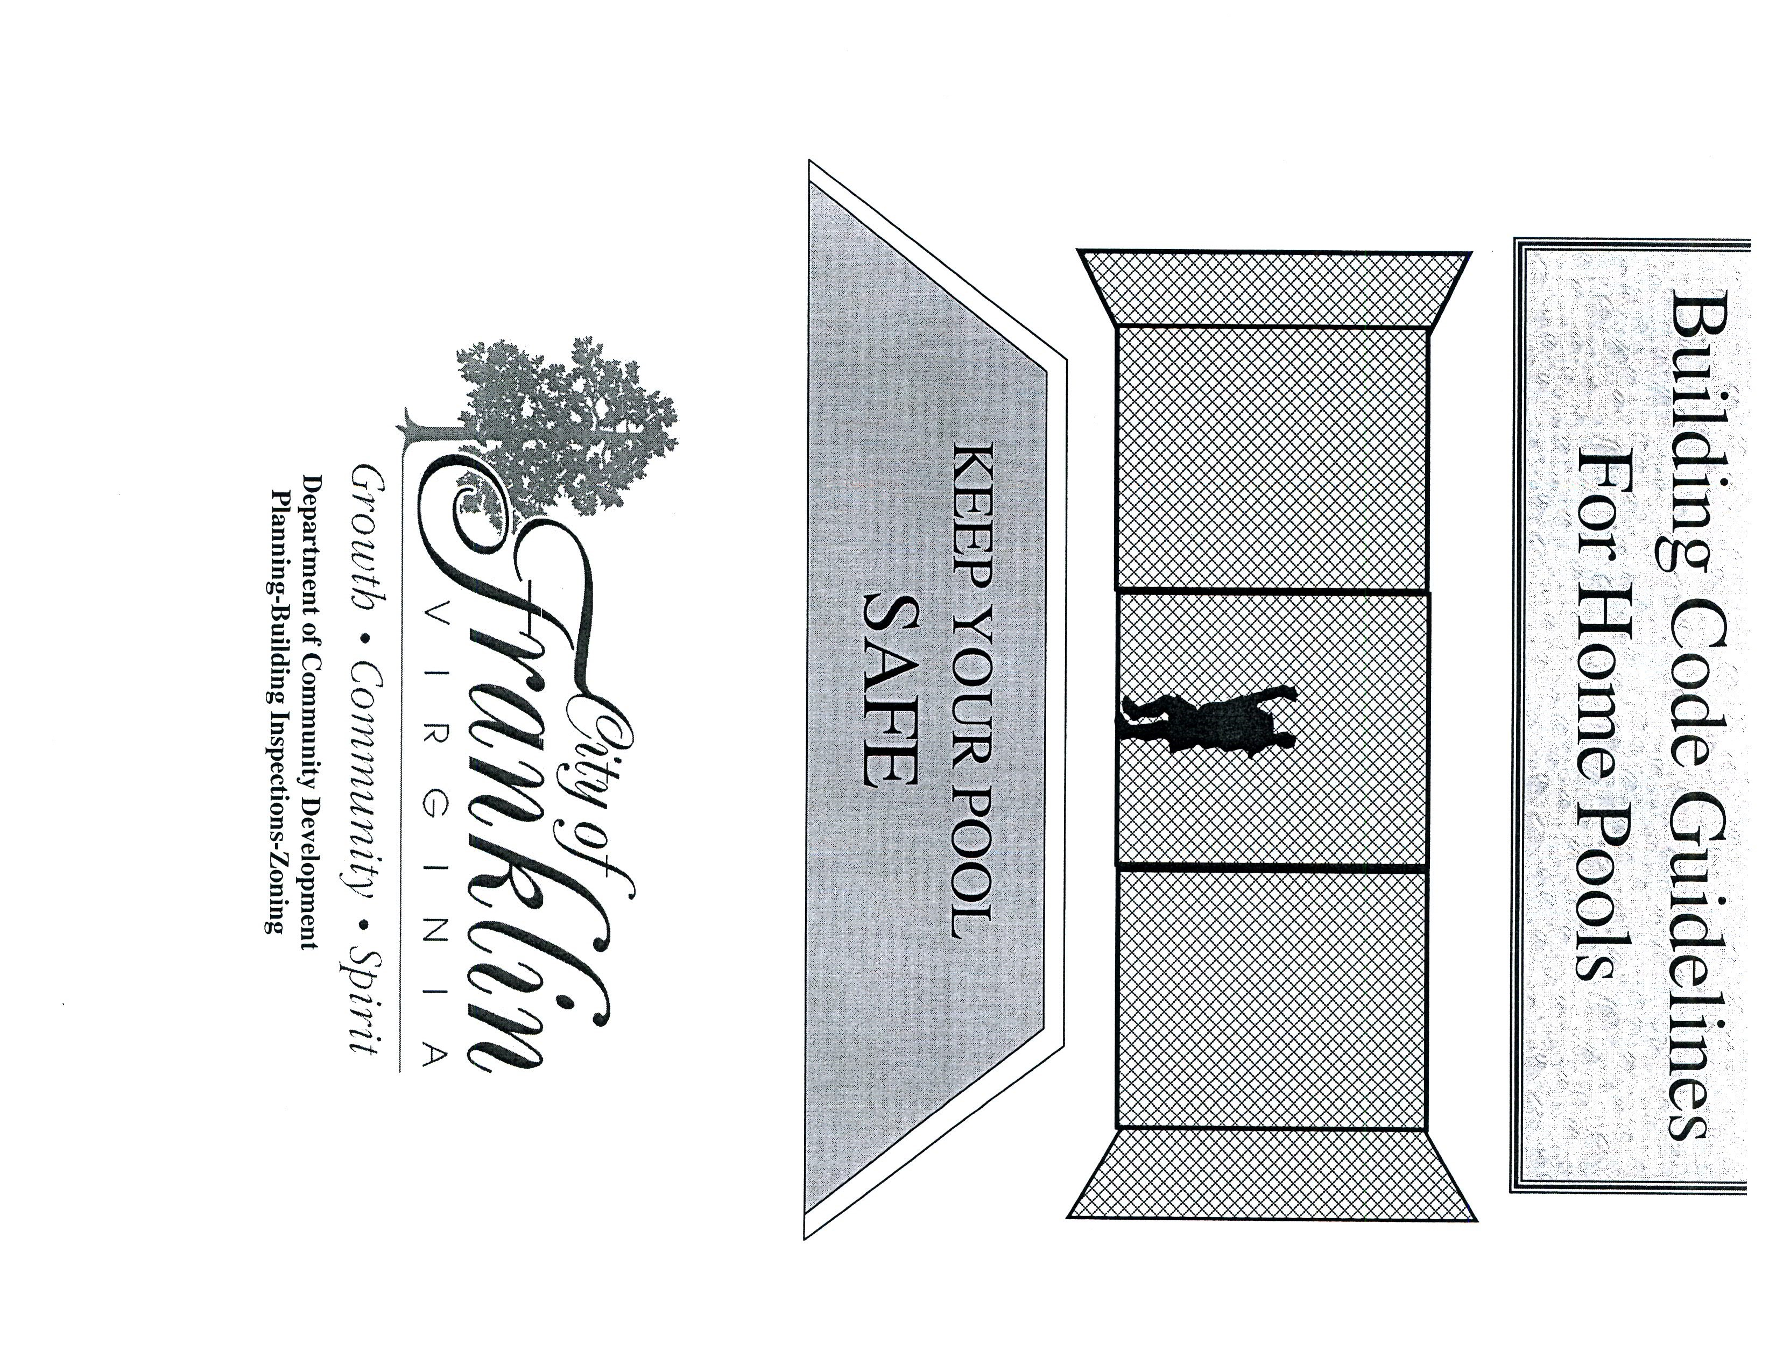
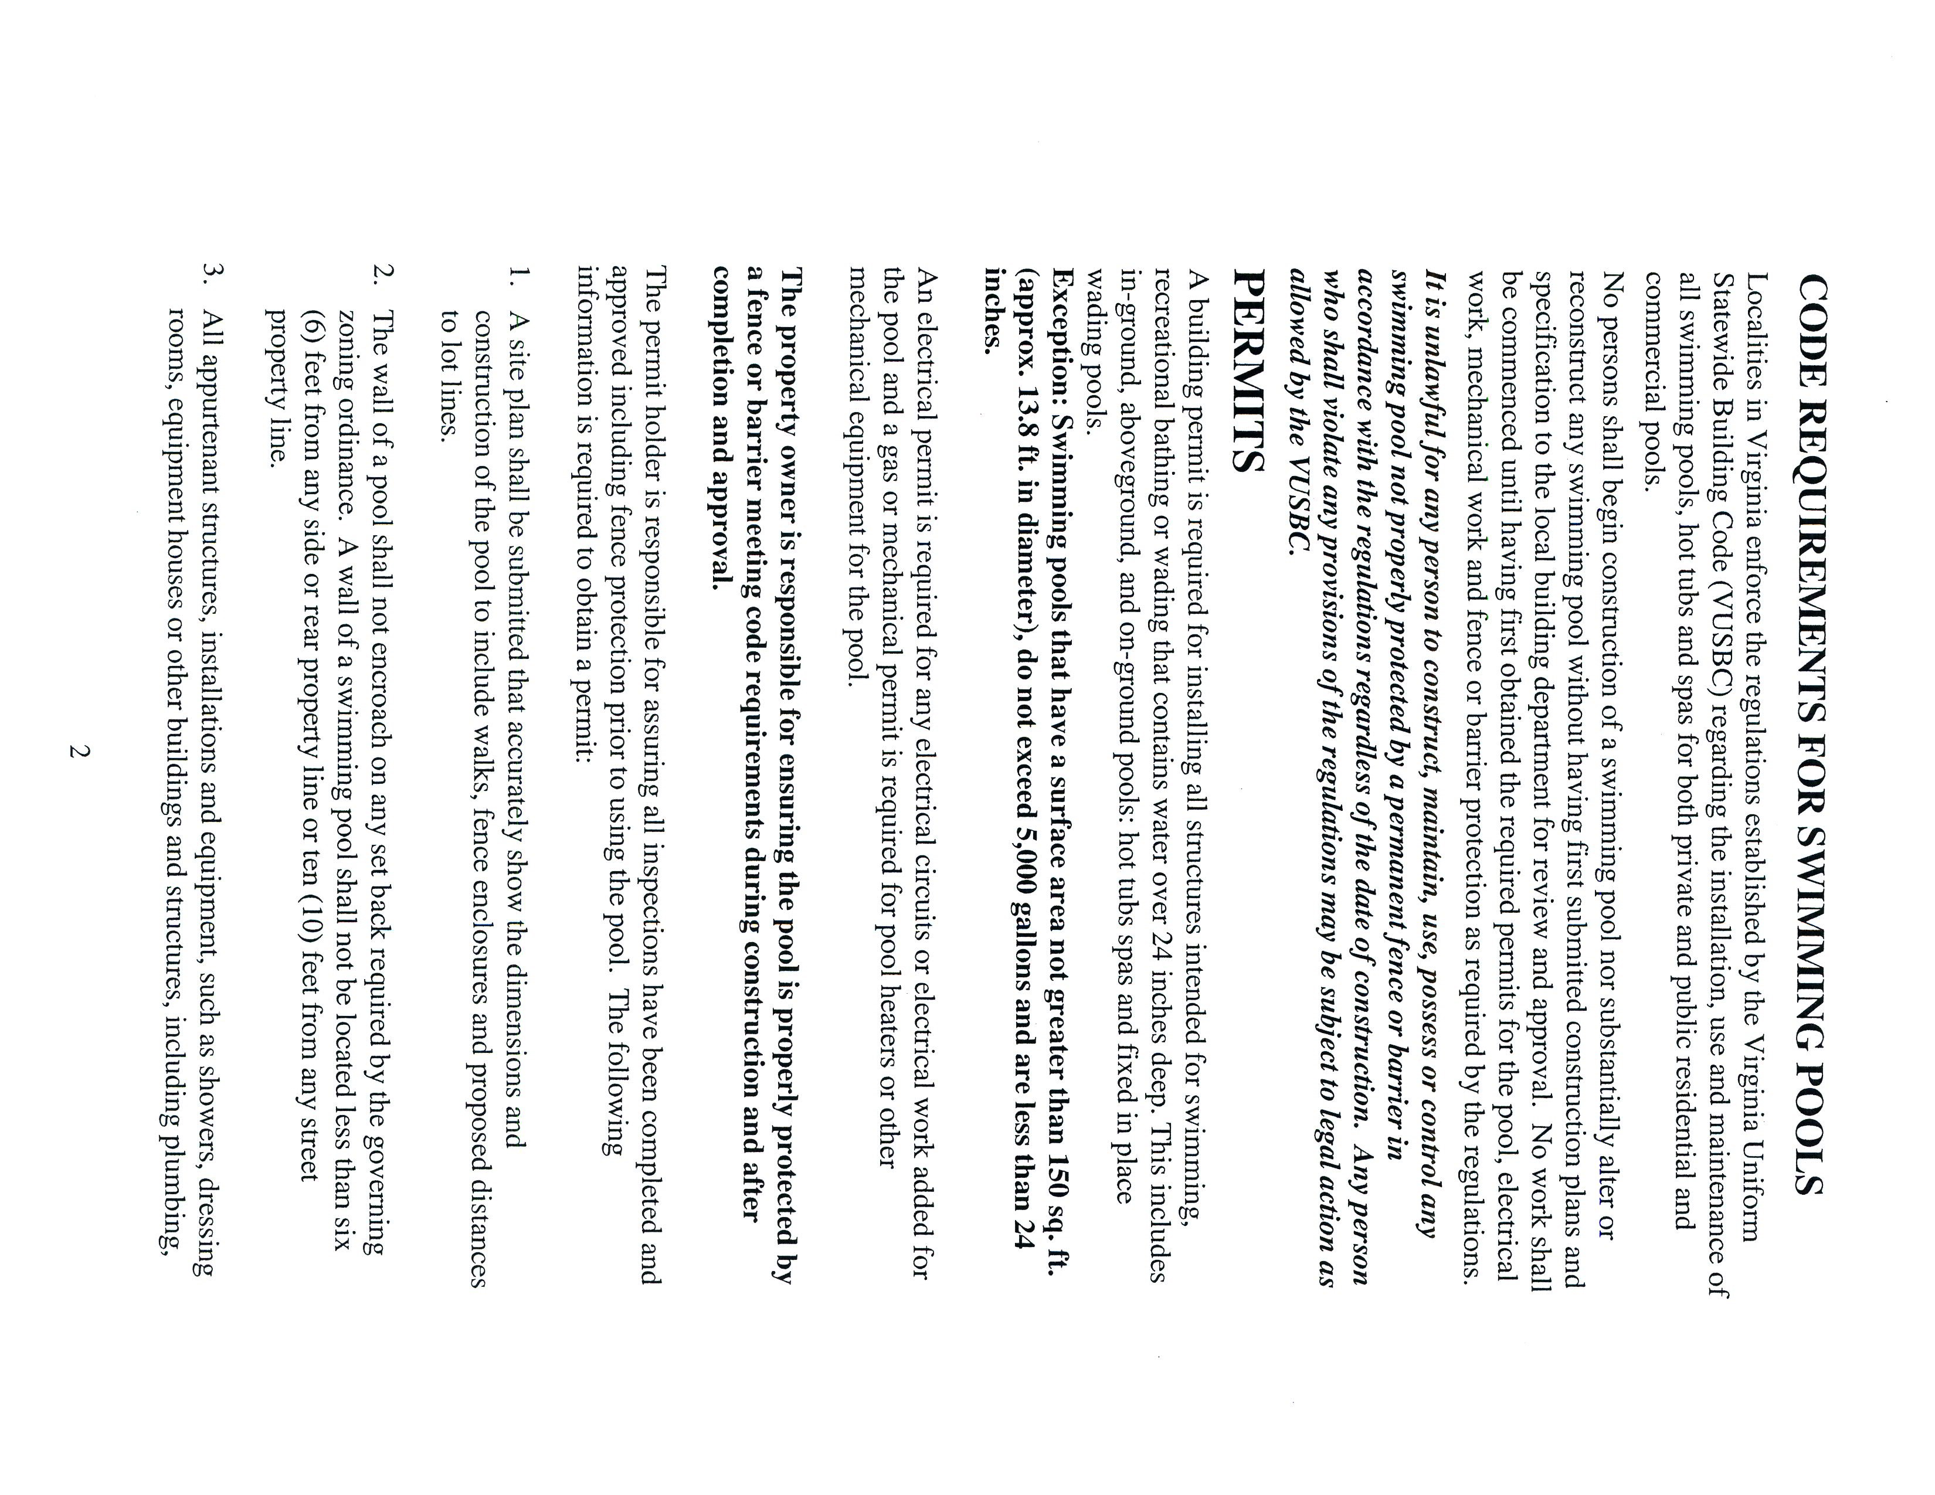
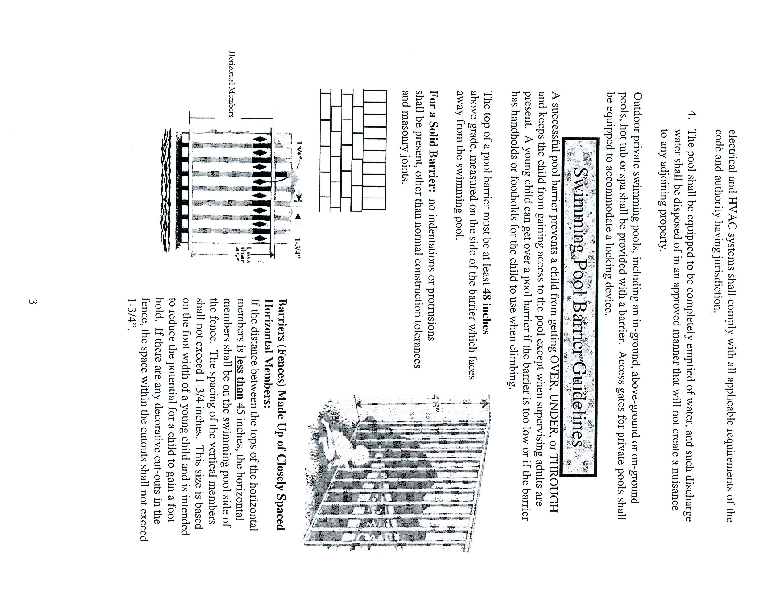
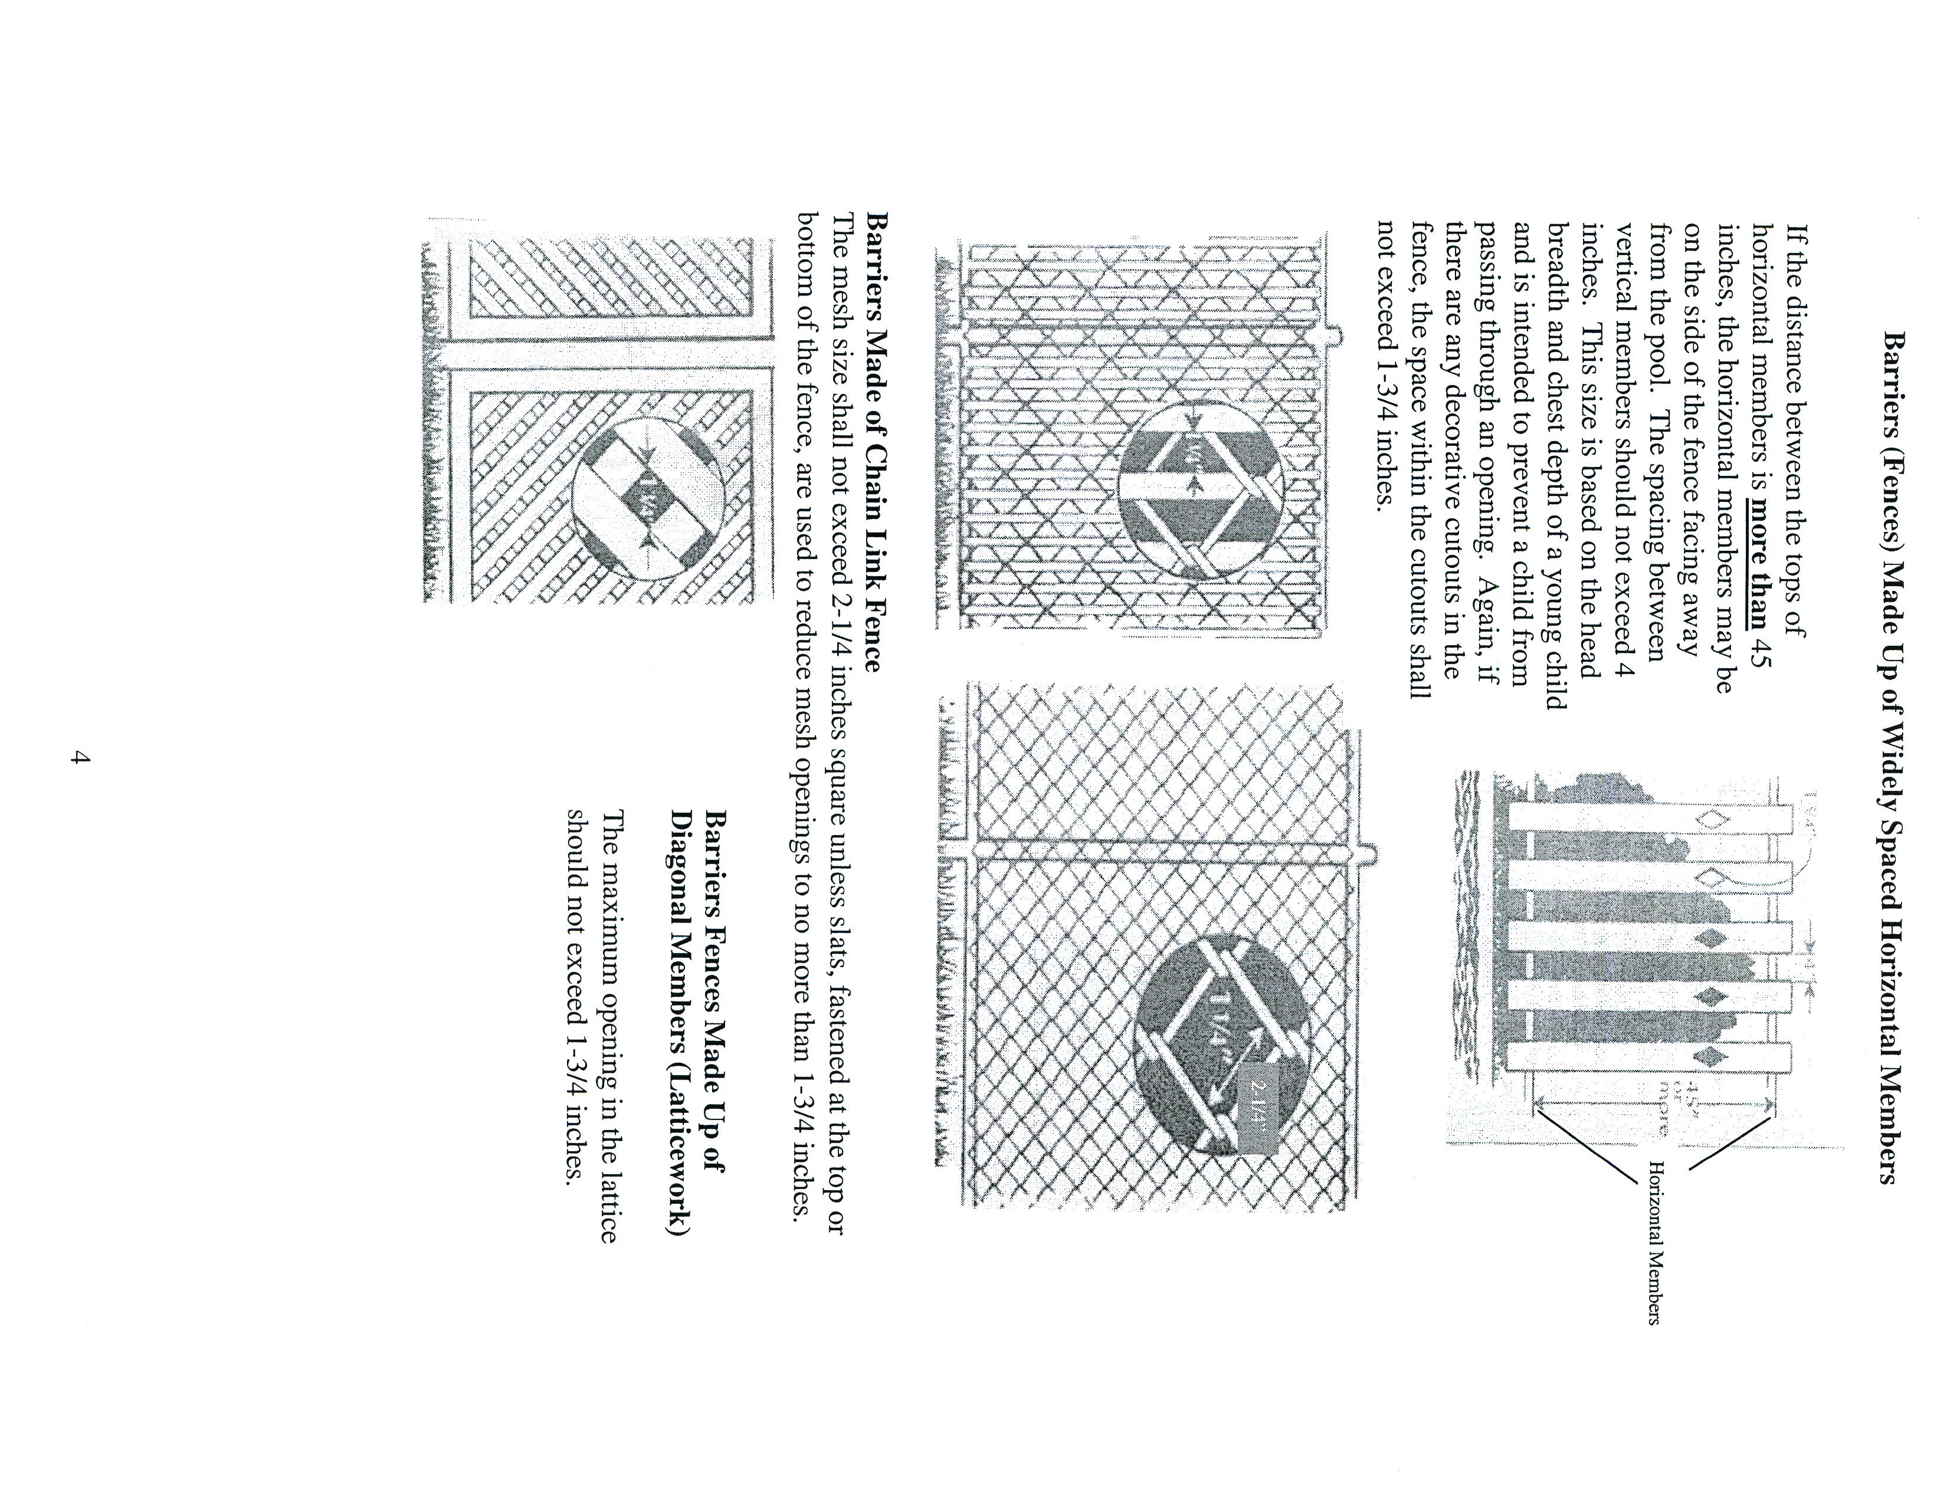
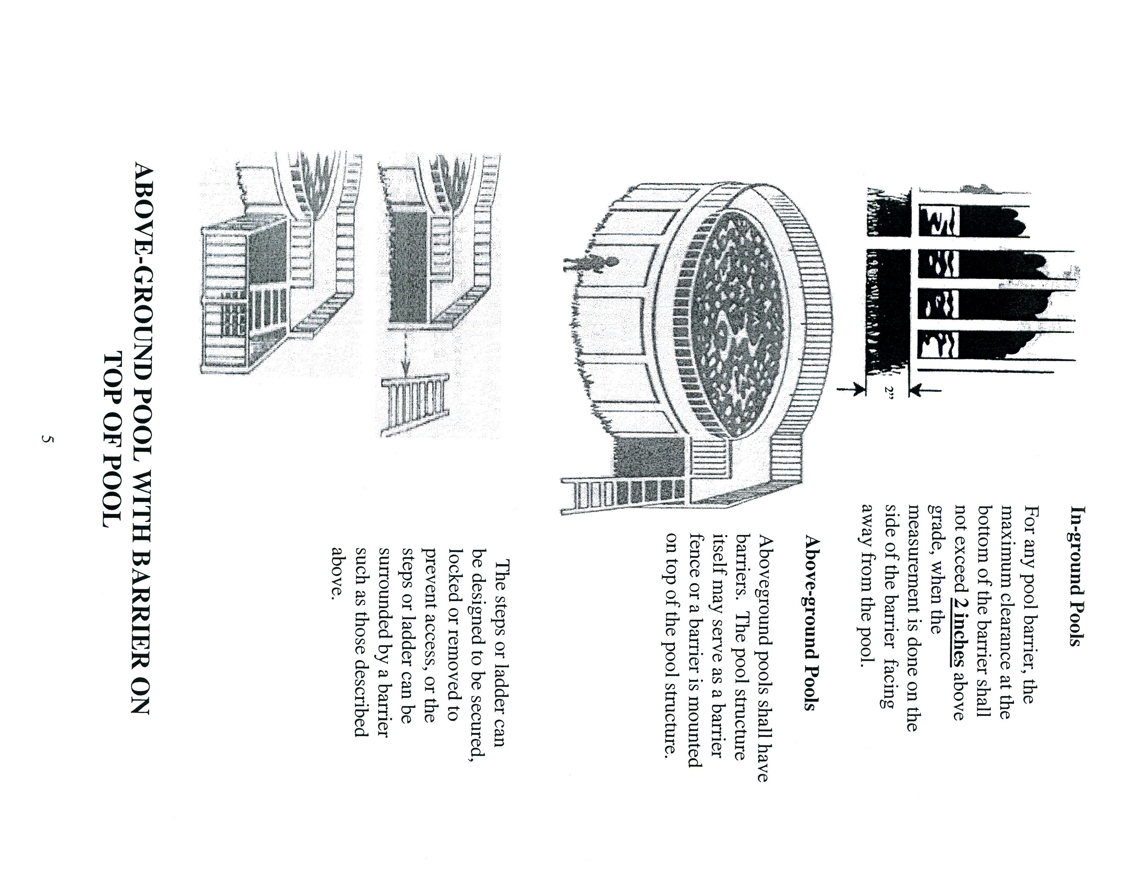
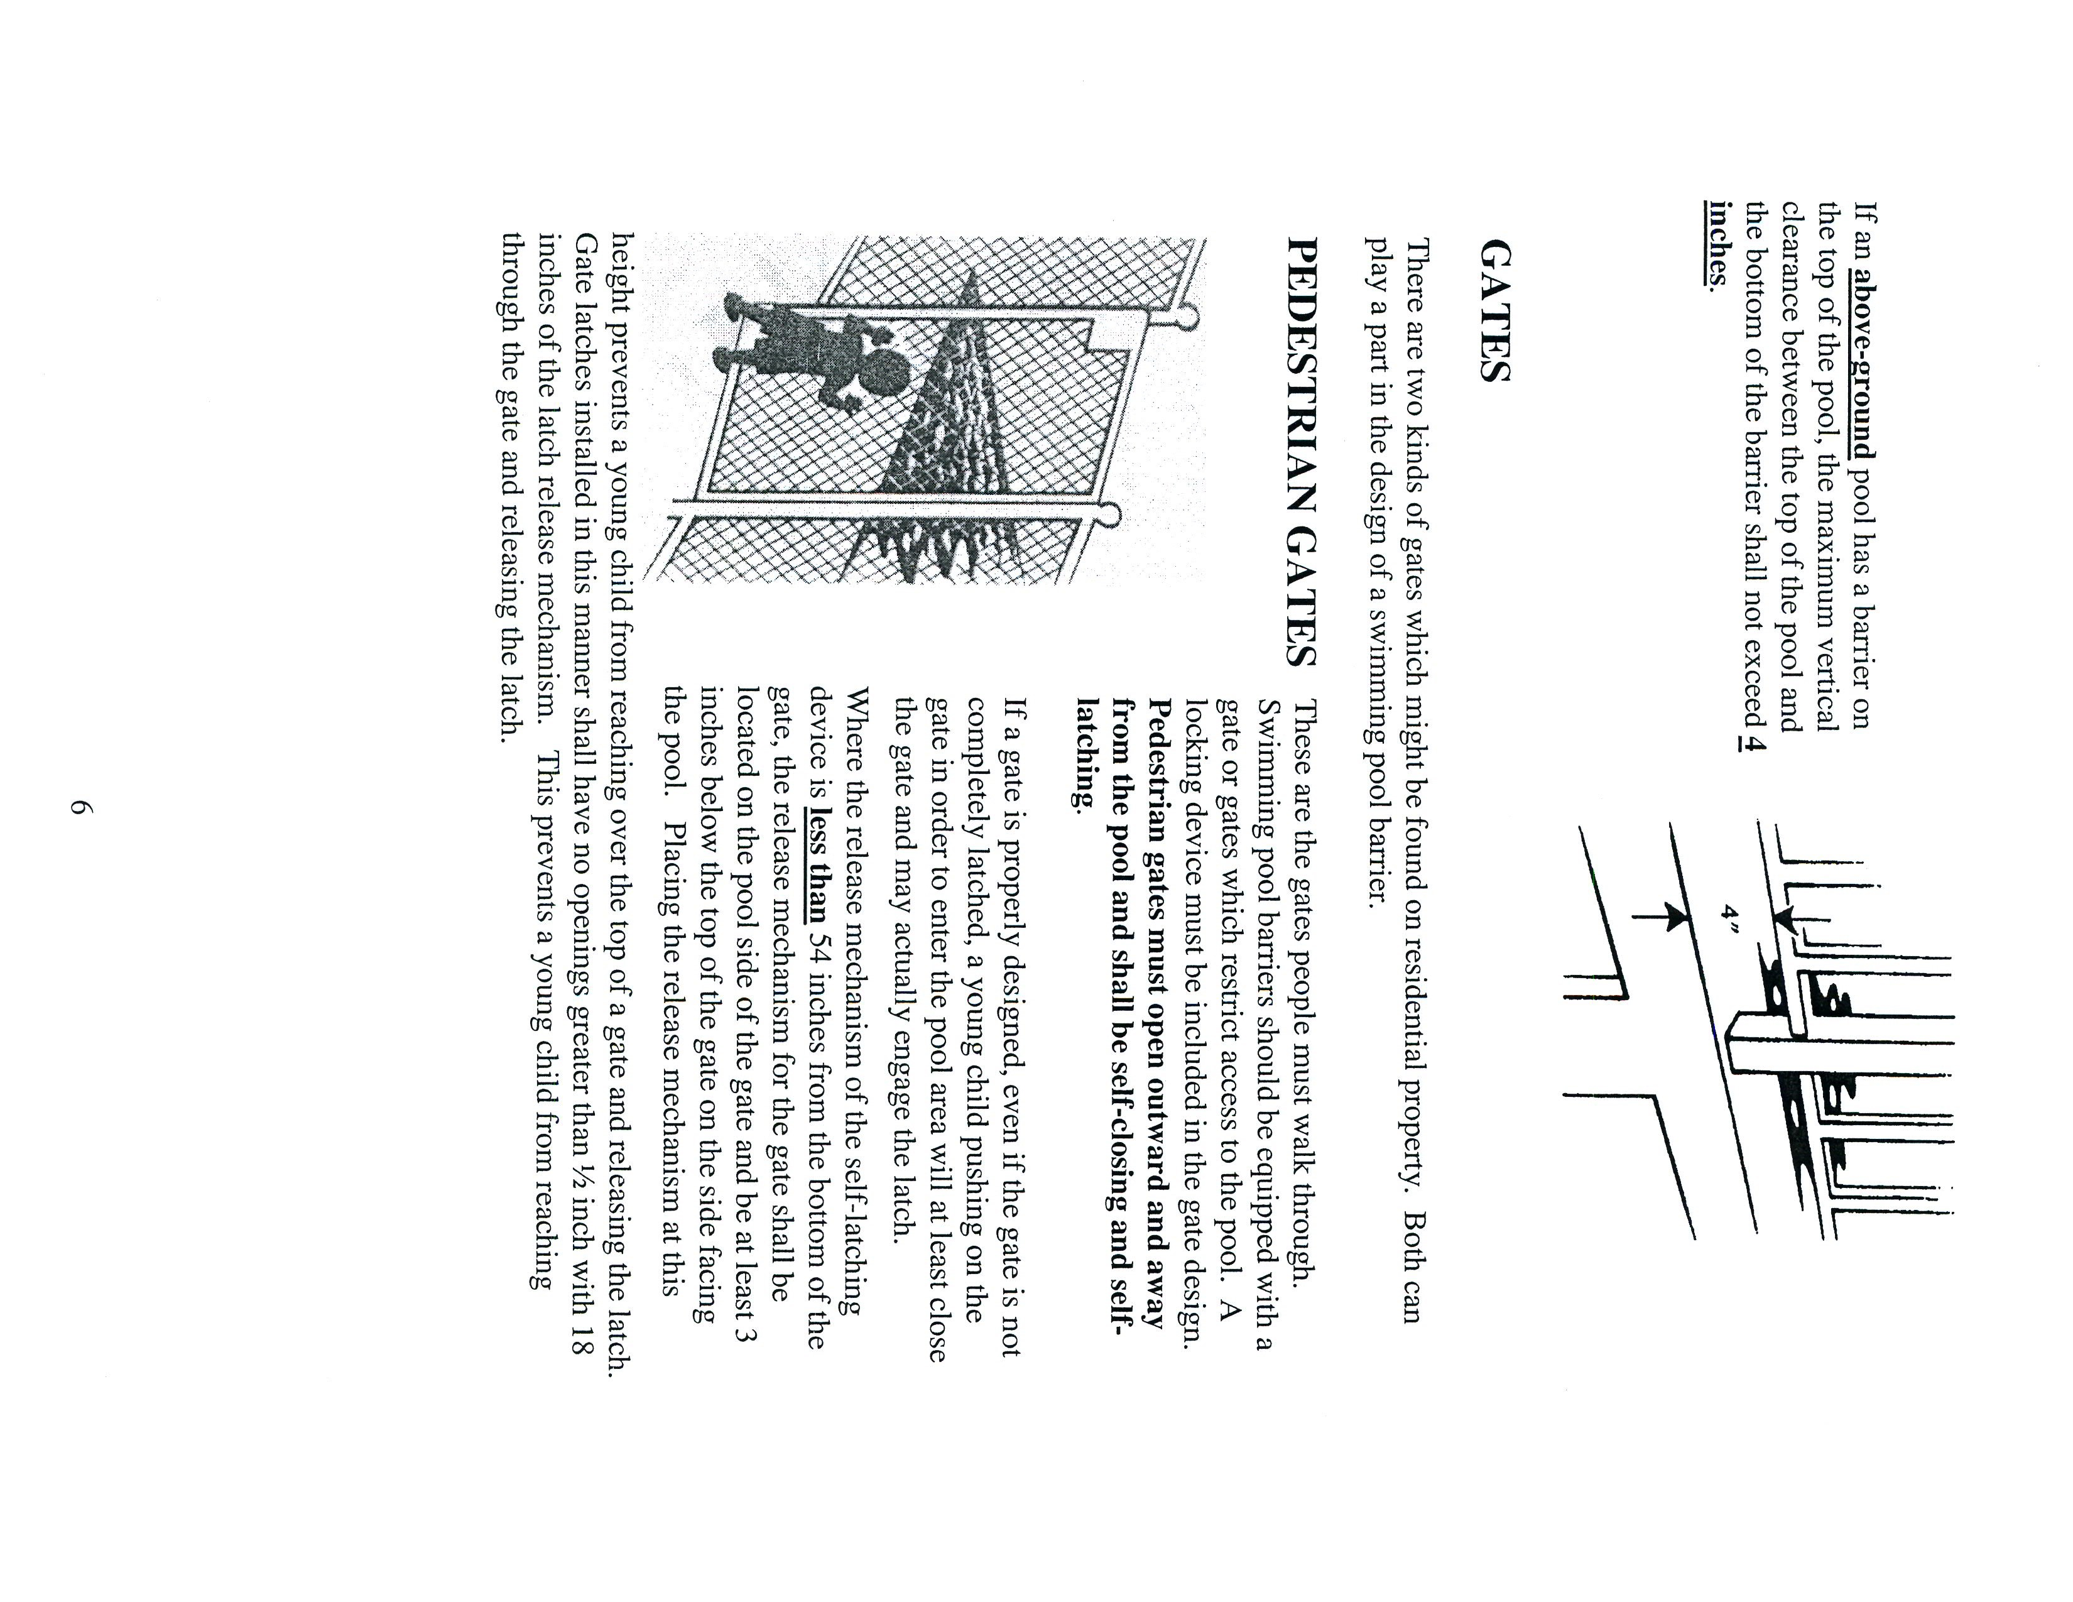
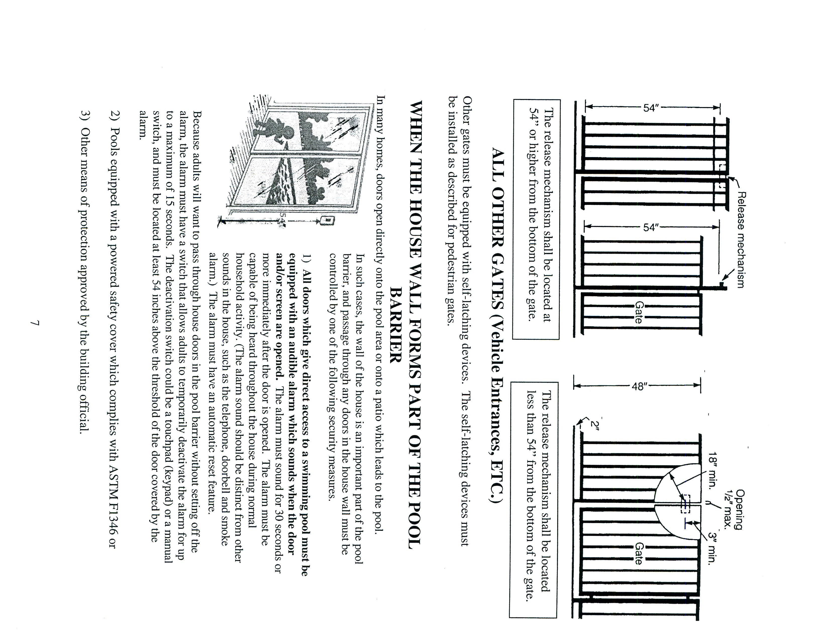

DEPARTMENT OF COMMUNITY DEVELOPMENT
BUREAU OF INSPECTIONS, PLANNING, ZONING
SAFETY DEVICES FOR SWIMMING POOLS

AFFIDAVIT
Definition: Any structure for swimming, recreational bathing, or wading that contains water over 24 inches deep, or a surface area greater than 150 square feet or exceed 5000 gallons. This includes in-ground, above-ground, and on-ground pool, hot tubs, spas and fixed in place wading pools.

I__________________________________________________ (occupant of property), of (home address) ________________________________________________, affirm that I am the occupant of a certain tract or parcel of land, Tax Map #_____________________ located at _______________________________________________________________. I further attest that I or my licensed swimming pool contractor have applied for a building permit to erect a residential swimming pool or spa, as defined above, on the above named property. I affirm that I am aware of the provisions, codes and directions of the current Virginia Uniform Statewide Building Code and it’s adopted International Swimming Pool and Spa Code concerning the safe erection of a swimming pool or spa including the requirement to erect and maintain an adequate barrier and/or enclosure surrounding the swimming pool or spa and adequate safety devices in accordance with the International Swimming Pool and Spa Code. I also affirm that I will insure that the required swimming pool, swimming pool barrier and/or enclosure and safety devices will be installed and pass final inspection by this office prior to the operation or use of the swimming pool or spa.
By affixing my signature to this document I swear and affirm the facts attested to in this one page document are accurate, complete and true to the best of my knowledge.

_____________________________________________ (Affiant signature)

The Affiant, __________________________________(print) has come before me, a Notary Public in the City of Franklin, VA., and sworn the facts and statements herein are accurate, complete and true to the best of his/her knowledge on this the _______ day of ______________, 20___
___________________________________ (Notary). (Print name) ______________________________ My commission expires on ______________________________

