**CITY CLIPS**

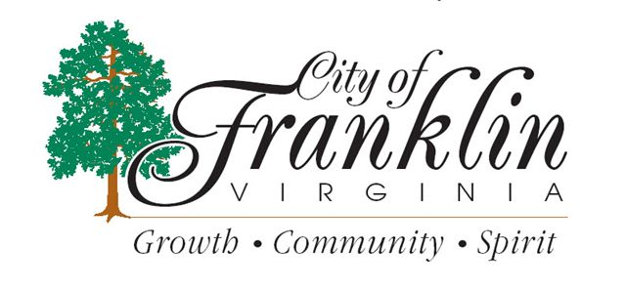

**DECEMBER 2015**

[www.franklinva.com](http://www.franklinva.com)

**IMPORTANT DATES TO REMEMBER:**

**Recycling Dates –** December 3rd, 4th, 17th, 18th, & 31st

*(All meetings below are held in Council Chambers at City Hall)*

**City Council Meeting –** December 14th

**School Board Meeting –** December 17th

**CITY OFFICES WILL BE CLOSED ON MONDAY, SEPTEMBER 7th FOR LABOR DAY**



**CITY OFFICES WILL BE CLOSED**

**DECEMBER 24th & 25th**

**FOR CHRISTMAS**

**Christmas Eve Garbage Schedule**:

**The City of Franklin *WILL* have regular Thursday trash pickup on Christmas Eve, December 24, 2015.**

**Christmas Day Garbage Schedule**:

**The City of Franklin *WILL NOT* have regular Friday trash pickup on**

**Christmas Day, December 25, 2015.**

**Friday’s route will be picked up on Monday along with Monday’s route.**

**The Public Works office will be closed and will reopen**

**Monday, December 28, 2015.**



Pet tags are now on sale.   Any pet in the City of Franklin must have a Pet Tag.  Pets must have an updated Rabies shot prior to purchasing your tag.  2016 Pet Tags may be purchased at the Treasurer’s office.  Deadline for purchasing your 2016 Pet Tag is January 31, 2016.

**Jingle Jingle!!!! Let’s Mingle**  
The City of Franklin Employee Holiday luncheon will be held **Wednesday, December 16** **at 11:30 am** at the Workforce Center. Hope to see all of you there.



**Supper with Santa at Fred’s Restaurant – Friday, December 11th**

**Breakfast with Santa at Mr. D’s Restaurant – Saturday, December 12th**

**Old Timey Christmas shopping Special day – Saturday, December 12th**

**Reminder:** The firm of Wampler-Eanes Appraisal Group, Ltd. will be performing the 2016 General Reassessment for the City of Franklin. State Law requires that a general reassessment reflect 100% market value for each property.

An appraiser from the Wampler-Eanes firm will personally inspect every parcel in the City, both taxable and non-taxable, to establish the current fair market value of the real estate, in accordance with state requirements.

The firm is beginning the process by completing a sales study to determine the general market values in the City of Franklin. Real Estate sales from the past year of all types of property are used to establish a base line of comparable value for assessment purposes. The fieldwork of inspecting every property will begin November 2015.

The appraisers will maintain an office at City Hall in the Commissioner of the Revenue’s Office. If residents are not home when an appraiser visits a property, they will leave a notice indicating that the property has been inspected. If they need additional information about your property, it will be marked on the notice to call the Real Estate Clerk at 757-562-4870.

**Important Notice from Blackwater Regional Library**

In an effort to be on the cutting edge of the public education industry, Blackwater Regional Library's Bookmobile will be undergoing a large scale upgrade to the services it provides to your citizens.

New services will include public internet access via Wi-Fi, a more comprehensive popular materials collection and stronger presence at the festivals and events that make your community great.

Blackwater Regional Library also plans on working closely with other non-profit educational organizations in your locality, ensuring the maximum amount of people are positively affected by everything the library has to offer.

In order to implement these changes successfully, the Bookmobile will be taken *off* of its current route beginning January 2016, with an expected return to service date in April 2016.

The sight of topped trees is all too common in the communities and along the roadways of America – trunks with stubby limbs standing naked in the landscape, trees stripped of all dignity and grace.

Trees are often topped because they grow into utility wires, interfere with views or solar collectors, or simply grow so large that they worry the landowner. But, as one arborist has said, Topping is the absolute worst thing you can do for the health of your tree.

## Why NOT to “Top:” 8 Good Reasons

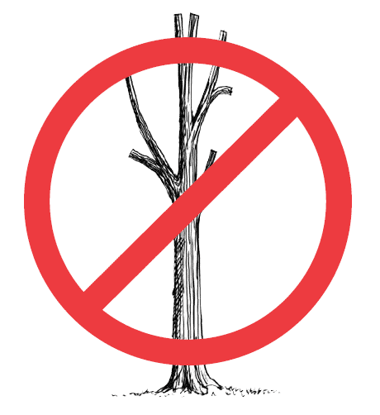

1. **Starvation:** Topping removes so much of the tree’s leafy crown that it dangerously reduces the tree’s food-making ability.
2. **Shock:** By removing the protective cover of the tree’s canopy, bark tissue is exposed to the direct rays of the sun. The resultant scalding can cause the tree’s death.
3. **Insects and Disease:** The exposed ends of topped limbs are highly vulnerable to insect invasion or decay fungi spores.
4. **Weak Limbs:** New branches that grow from a stubbed limb are weakly attached and more liable to break from snow or ice weight.
5. **Rapid New Growth:** Instead of controlling the height and spread of the tree, topping has the opposite effect. New branches are more numerous and often grow higher than before.
6. **Tree Death:** Some tree species can’t tolerate major branch loss and still survive. At best, they remain weak and disease-prone.
7. **Ugliness:** A topped tree is a disfigured tree. Even with new growth it never regains the grace and character of its species.
8. **Cost:** The true cost of topping is often hidden – lower property values, expense of removal and replacement if the tree dies.

## Proper Pruning—The Alternative to Topping

When a decision is made to reduce the size of an older tree, it can be topped, or it can be pruned properly. Although the speed and nature of re-growth will depend on species and local factors, any comparison between irresponsible topping and competent pruning will be dramatic. Qualified arborists use ‘crown reduction’ to control height when necessary. Selected limbs are removed at their junction with the trunk or a limb at least 1/3 the diameter of the removed limb.

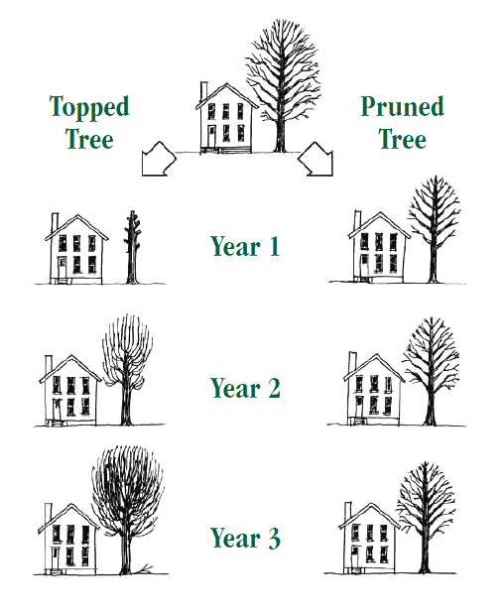

**Year 1:** The topped tree is an ugly stub and a remnant of a once lovely tree. If pruned properly, the tree’s size is reduced but form and beauty are retained.

**Year 3:** Vigorous sprouts have sprung out of the topped tree in large numbers and are growing with abnormal rapidity. The pruned tree adds growth, but it does so more slowly and distributes it more normally.

**Year 6:** In a relatively short time, the topped tree is as tall – and far bushier and more dangerous – than it was to begin with. The properly pruned tree is safer, more beautiful, and its size is better controlled.

## For More Information

Call 1-888-448-7337 Monday-Friday 8:00 AM to 5:00 PM CST

Tree City USA is an Arbor Day Foundation program in cooperation with:

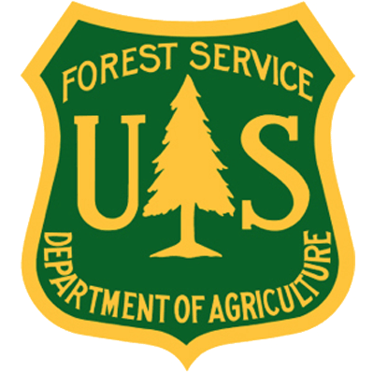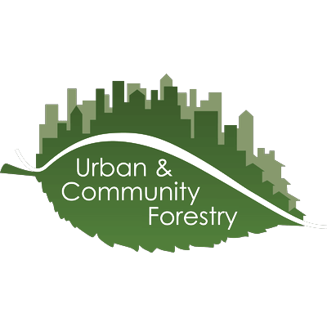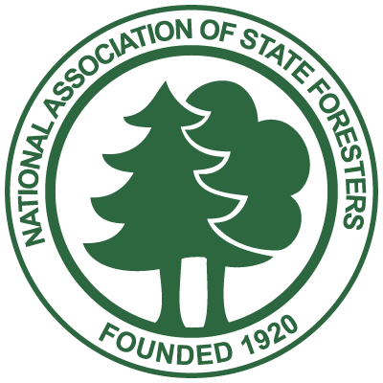

**Monthly Topic from the Safety & Wellness Committee:**

In July 1997, the City of Franklin’s Workplace Violence Prevention Policy went into effect. Workplace violence is any act or threat of physical violence, harassment, intimidation, or other threatening disruptive behavior that occurs at the worksite.

Any employee should report concerns for safety, including acts or threats of violence or other violations of this policy to his or her immediate supervisor, to Human Resources staff, or to any member of management.

• It is better to report concerns immediately before things escalate and someone gets hurt.

• Do not make jokes about committing or threatening violence.

• Be aware of and report to management unauthorized individuals in your work environment.

For more information, please review Section 710 of the Personnel Policy Manual.

