**CITY CLIPS**



**OCTOBER 2015**

[www.franklinva.com](http://www.franklinva.com)

**IMPORTANT DATES TO REMEMBER:**

**Recycling Dates –** October 8th, 9th, 22nd, & 23rd

*(All meetings below are held in Council Chambers at City Hall)*

**City Council Meeting –** October 26th

**School Board Meeting –** October 15th

**Planning Commission Meeting -** October 22nd

**CITY OFFICES WILL BE CLOSED ON MONDAY, SEPTEMBER 7th FOR LABOR DAY**

**~~~~~~~~**

**CITY OFFICES WILL BE CLOSED ON MONDAY, OCTOBER 12TH FOR COLUMBUS DAY**

**~~~~~~~~**

**Columbus Day Garbage Schedule**:

**The City of Franklin *WILL* have regular Monday trash pickup on Columbus Day, October 12, 2015. The Public Works office will be closed and will reopen**

**Tuesday, October 13, 2015.**

Due to INCLEMENT WEATHER

The 33rd Annual FRANKLIN FALL FESTIVAL

has been RESCHEDULED to November 13th & 14th

***“Your most unhappy customers are your greatest source of learning.”* – Bill Gates**

The Franklin Business Incubator wants you to have a successful holiday season and year to come so we invite you to join us at the “Getting it Right with Customer Service” workshop on October 8th. This event will be held from 6:00 PM to 8:00 PM at the Franklin Business Incubator. This event is presented by Chris Zobel, Senior Area Manager for the US Small Business Administration. He has years of experiences and wants to help you and your employees retain and gain customers! Light refreshments will be provided. Please RSVP by October 6th by calling 757-562-1958 or emailing [acotton@franklinsouthamptonva.com](mailto:acotton@franklinsouthamptonva.com).

**Fall Amnesty Week**

The City of Franklin Department of Public Works and The Department of Community Development are pleased to announce that they have declared October 5-9, 2015, as **Fall Amnesty Week.** In an effort to assist City residents in a major fall cleaning, these days are set aside by the City to allow resident owners and tenants (current city customers only) a temporary pardon to rid properties of unsightly accumulations of trash, junk and debris without cost to residents for pickup and removal.

**The following items may be placed at the curb for pickup on October 5,6, 7, 8 and 9 *ON YOUR REGULAR TRASH DAY****.*

* **Unused objects from your yard such as lawnmowers, containers, old tires, etc.**
* **Unused objects from your home such as appliances, furniture, TV’s, etc.**
* **Unused deteriorated building materials and firewood.**

Any items placed at curbside should be left in neat piles adjacent to the street. Please be mindful of obstructions when placing those items to allow for safe collection by our crews. Obstructions can be parked vehicles, power poles, overhead utility lines, mailboxes, fire hydrants, signs, trees or hedges, or any fixed object that interferes with the safe collection of the items placed at curbside.

**Caution: No demolition debris, trees over 6’’ in diameter, lot-clearing materials, paint or other hazardous materials will be collected. Limbs must be cut to ordinance lengths (4’ long) and piled neatly at curbside. Please call 757-562-8564, if you are in doubt about any items before placing them at the curb.**

**Items not available for pickup by the City, may be carried to the SPSA Transfer Station on Route 671 (General Thomas Hwy) Phone Number is 757-420-4700 ext 527.**

***For further information contact Franklin Public Works at 757-562-8564***



Want to know why you should use QuickBooks and whether the desktop or online version is best for you? Great! You need to join us at the Lunch n’ Learn on October 21st from 12:00 PM to 1:30 PM at the Franklin Business Incubator. Sandra Purvis who is a certified proadvisor for QuickBooks and owns Conquering QuickBooks will be here to teach you all the benefits of QuickBooks. Simply RSVP by October 19th by calling 757-562-1958 or emailing [acotton@franklinsouthamptonva.com](mailto:acotton@franklinsouthamptonva.com).

Franklin Department of Social Services will start accepting applications for the fuel (heating) component for the Energy Assistance Program starting on Tuesday, October 13, 2015.

The program deadline is Friday, November 13, 2015.  All applications MUST be received by 5:00pm on Nov. 13, 2015 to be processed.

Customers may apply for the EAP in a variety of methods:

* Through the customer service portal on the internet: [www.CommonHelp.virginia.gov](http://www.CommonHelp.virginia.gov).  These applications can be completed earlier than October 13, 2015.  There are computers available at Franklin DSS for customers to use to apply for all benefit programs.
* At the local department of social services.   Paper applications will be available starting on Tuesday, October, 13, 2015.

Pre-approved letters and pre-printed applications are generally mailed by the state during the last full week of September.  Those customers are encouraged to submit their completed application as soon as possible.

Please note that the local Agency will process the application but the payment is completed by the state.   Once the case has been processed and approved in the EAP system, the amount the customer is eligible for is set by the state during Benefit Determination time in early December, and a Fuel Credit Authorization is sent to the vendor.  Upon receipt of that completed Credit Authorization, the state then prepares the payment to be made.

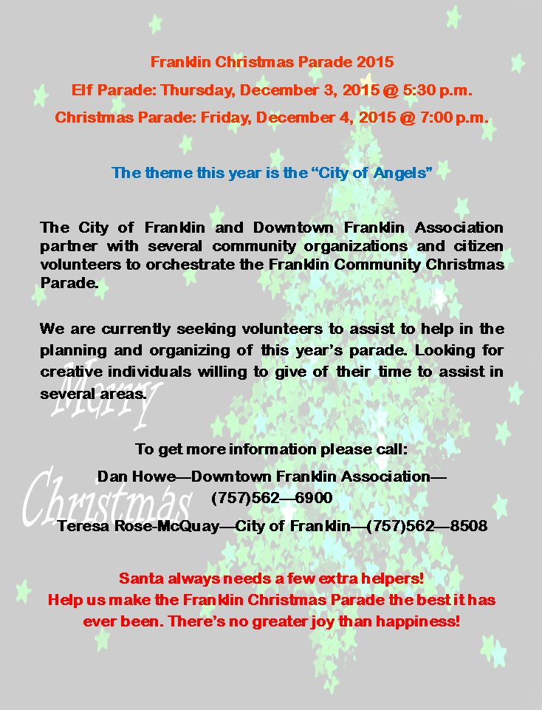

**Monthly Topic from the Safety & Wellness Committee:**

This October, The City of Franklin’s Safety, Health & Wellness Committee is proud to participate in National Breast Cancer Awareness Month. Breast cancer is the second most common kind of cancer in women. About 1 in 8 women born today in the United States will get breast cancer at some point.

The good news is that many women can survive breast cancer if it’s found and treated early.

• If you are a woman age 40 to 49, talk with your doctor about when to start getting mammograms and how often to get them.

• If you are a woman age 50 to 74, be sure to get a mammogram every 2 years. You may also choose to get them more often.

Talk to a doctor about your risk for breast cancer, especially if a close family member of yours has had breast or ovarian cancer. Your doctor can help you decide when and how often to get mammograms.

For more information, visit [www.cancer.org/cancer/breastcancer/](http://www.cancer.org/cancer/breastcancer/)



FCPS FALL SPORTS SCHEDULES



**Varsity Football (2015)  
Head Coach: Darren Parker**

|  |  |  |  |
| --- | --- | --- | --- |
| **Date** | **Time** | **Opponent** | **Location** |
| 10/2 | 7:00 PM | Surry | Away |
| 10/9 | 7:00 PM | Brunswick | Home |
| 10/16 | 7:00 PM | Sussex | Away |
| 10/23 | 7:00 PM | Greensville  (Homecoming) | Home |
| 10/30 | 7:00 PM | Windsor | Away |
| 11/6 | 7:00 PM | Southampton | Home |



**Cross Country (2015)  
Head Coach: Angel Cashwell**

|  |  |  |  |
| --- | --- | --- | --- |
| **Date** | **Time** | **Opponent** | **Location** |
| 10/5 | 4:30 PM | District | Northampton |
| 10/7 | 4:30 PM | District | Southampton |
| 10/14 | 4:30 PM | District | Franklin |
| 10/21 | 4:30 PM | District | Park View |



**Volleyball (2015)  
Head Coach: Shawn Denne**

|  |  |  |  |
| --- | --- | --- | --- |
| **Date** | **Time** | **Opponent** | **Location** |
| 10/1 | 5:30 PM | Northampton | Away |
| 10/6 | 5:30 PM | Surry | Home |
| 10/8 | 5:30 PM | ARGS | Home |
| 10/13 | 5:30 PM | Park View | Away |
| 10/15 | 5:30 PM | Sussex | Home |
| 10/20 | 5:30 PM | Brunswick | Away |
| 10/22 | 5:30 PM | Windsor | Away |
| 10/27 | 5:30 PM | Southampton | Home |
| 10/29 | 5:30 PM | Greensville | Home |

