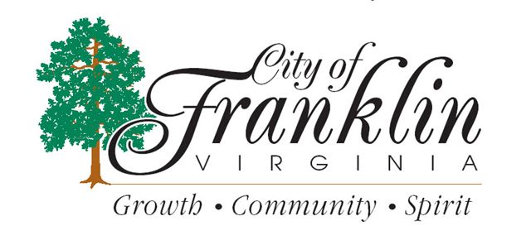 CITY CLIPS
JULY 2015

www.franklinva.com
IMPORTANT DATES TO REMEMBER:

Recycling Dates – July 2nd, 3rd, 16th, 17th, 30th, & 31st
(All meetings below are held in Council Chambers at City Hall)
City Council Meetings – July 13th & 27th
School Board Meeting – July 22nd
Planning Commission Meeting - July 23rd

CITY OFFICES WILL BE CLOSED ON FRIDAY, JULY 3rd FOR INDEPENDENCE DAY
~~~~~~~~
Independence Day Garbage Schedule:
The City of Franklin WILL have regular Friday trash pickup on July 3, 2015. The Public Works office will be closed and will reopen
Monday, July, 6, 2015.

The City of Franklin Department of Public Works will be hosting a March of Dimes cookout in July. Further details will be forthcoming.

The Commissioner of the Revenue’s Office is now taking applications for Tax Relief for the Elderly or Disabled Persons. Complete or partial real estate tax exemption is provided on real estate owned by and occupied as the sole dwelling of qualified persons who are either 1.) Sixty-five (65) years of age or older; or 2.) Permanently or totally disabled and are eligible according to the other terms of the ordinance.

The total combined income of the owner and the owner’s relatives living in the household during the 2014 calendar year may not exceed $30,000. The net combined financial worth of the owner or owners as of December 31, 2014 must not exceed $60,000.

If you meet the above qualifications, you may obtain an application in the Commissioner of the Revenue’s office in City Hall from 8:30 to 5:00. Applications must be filed on or before August 3, 2015.
Monthly Topic from the Safety & Wellness Committee:

Many of us spend the better part of the year looking forward to the summer months. The sunny weather inspires vacation plans, outdoor activities, summer festivals, and trips to the pool or beach. With so many activities packed in, it's easy to overlook things. One of the most important things to remember when planning to be outside in the summer is how to protect yourself ultraviolet (UV) rays.

July is UV Safety Month. As we enjoy the beautiful summertime weather, we need to keep in mind several issues about the effects of the sun’s ultraviolet radiation. We need sunshine. It helps with our body’s production of Vitamin D and has been tied to issues of depression in some people who don’t get enough. However, overexposure to the sun can lead to a variety of health risks. You may be surprised about some of the specific dangers of sun exposure and how you can protect yourself.

There are two main types of UV light, UVA and UVB. UVB is what gives you your sunburn and is responsible for some types of skin cancers. UVA rays are the ones that can make the skin leathery and wrinkly in appearance and these also can contribute to certain skin cancers. (An easy way to remember: "A" is for aging and "B" is for burning). Both types are harmful to you in different ways.

UV light can be harmful to the skin as many of us know who have been badly sunburned. However, it can also be very bad for our eyes. Eye structures such as the cornea, retina, and lens are damaged from UV radiation, so protecting your eyes is vital.

