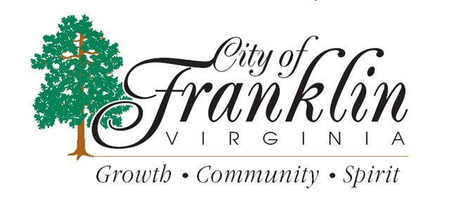
JOINT CALLED MEETING OF THE
FRANKLIN CITY COUNCIL
&
THE FRANKLIN CITY SCHOOL BOARD
Wednesday, October 30, 2013
Paul D. Camp Community Workforce Development Center
Technology Theater
Room 202
6:30 P.M.
207 W. Second Avenue
Franklin, VA 23851

