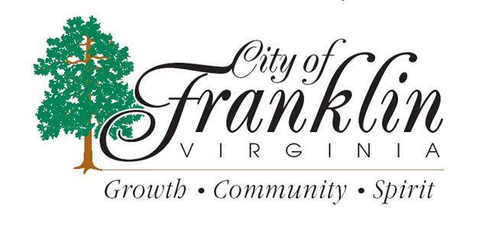

NOTICE OF A COMMUNITY MEETING WITH THE MAYOR AND WARD 3, 4 & 5 CITY COUNCIL MEMBERS
TUESDAY, OCTOBER 29, 2013
_________________________________

RAYSTINE D. JOHNSON, MAYOR
GREG MCLEMORE, (WARD 3)
MONA MURPHY, (WARD 4) MARY HILLIARD, (WARD 5)

These Members of City Council Along With Selected City Staff Will be available to accept questions and listen to concerns at
The Dr. Martin Luther King, Jr.
Community Center
683 Oak Street
Time: 7:00 P.M.

