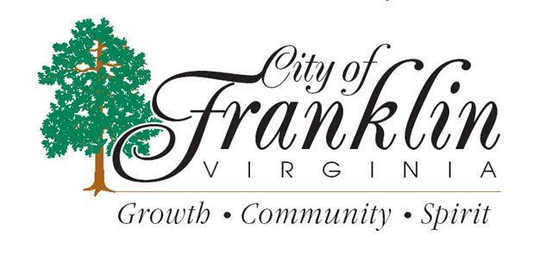
WORK SESSION
Monday, February 11, 2013
At 6:00 p.m.
FSEDI & HOLLINGSWORTH PARTNERSHIP UPDATE WITH RE: PRETLOW INDUSTRIAL PARK
____________________
MEETING OF THE
THE FRANKLIN CITY COUNCIL
MONDAY, February 11, 2013
AT 7:00 p.m.
City Hall Council Chambers
207 W. Second Avenue
Franklin, VA 23851
--------------------------------------------------
THIS IS A REGULAR SCHEDULED
CITY COUNCIL MEETING

