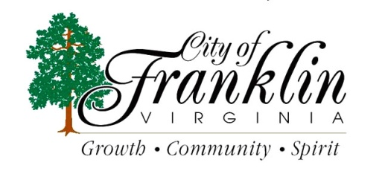

As a reminder the third Amnesty Week of 2021 is, August 16th – August 20th 2021 on your regular trash day only. In an effort to assist City residents in a major cleaning, these days are set aside by the City to allow residential owners and tenants (current city customers only) a temporary pardon to rid properties of unsightly accumulations of trash, junk and debris without cost to residents for pickup and removal.
Any items placed at curbside should be left in neat piles adjacent to the street. Please be mindful of obstructions when placing those items to allow for safe collection by our crews. Obstructions can be parked vehicles, power poles, overhead utility lines, mailboxes, fire hydrants, signs, trees or hedges, or any fixed object that interferes with the safe collection of the items placed at curbside.
Caution: NO demolition debris, trees over 6’’ in diameter, lot-clearing materials, paint or other hazardous materials will be collected. Limbs must be cut to ordinance lengths (4’ long) and piled neatly at curbside. Please call 757-562-8564, if you are in doubt about any items before placing them at the curb.
Thank you for your assistance in keeping our City clean!

