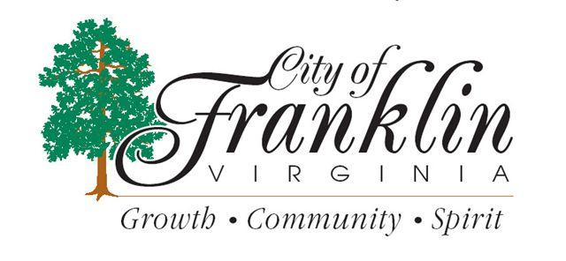
___________________

City Council will meet on
Monday, July 26, 2021
at 6:00 p.m. for a
Closed Session Work Session pursuant to Virginia Code Section 2.2-3711-A-3
for discussion or consideration of the acquisition of real property.

City Council will meet
at 7:00 P.M.
for a
Regular City Council Meeting.

Located at: City Hall Council Chambers
207 W. Second Avenue
Franklin, VA 23851
_______________

