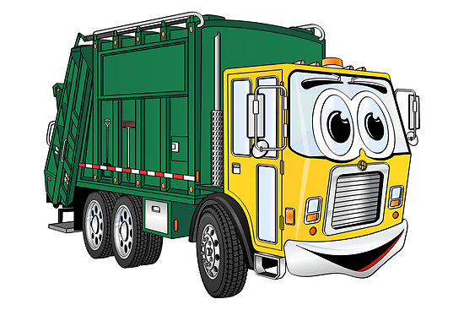
city of franklin
quarterly Amnesty collection Schedule for 2021
First Quarter: February 8, 2021 through February 12, 2021
Second Quarter: May 10, 2021 through May 14, 2021
Third Quarter: August 16, 2021 through August 20, 2021
Fourth Quarter: November 15, 2021 through November 19, 2021
*only on your regular trash day
Our City Council is committed to making our City a clean and inviting place to live. Our hope is that increasing the opportunity of Amnesty Collections for our citizens we can all work together to keep our city clean and beautiful. Thank you for your help with this and if you have any questions concerning these collection schedules please call the public works department at 757-562-8564.
Franklin City manager, Amanda C. Jarratt
* City of Franklin resident owners and tenants only.

