TREASURER’S OFFICE
IMPORTANT NOTICE!!
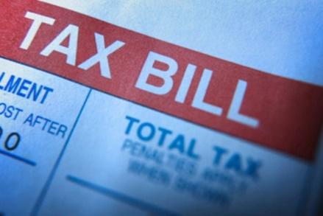
The City’s 2020 Real Estate and Personal Taxes
are due DECEMBER 07, 2020.
To avoid the 10% penalty and interest please pay on or before the December 07 due date. If you have yet to receive your tax bill, please call the Treasurer’s Office at 757-562-8519 or 757-562-8540.

