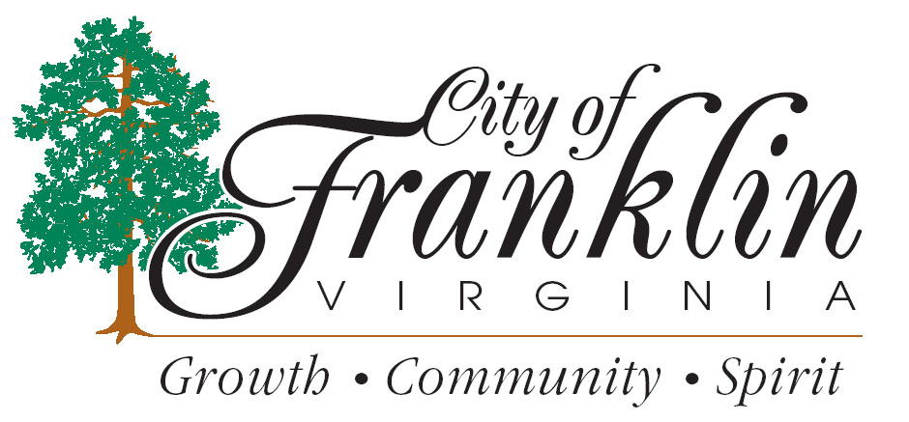
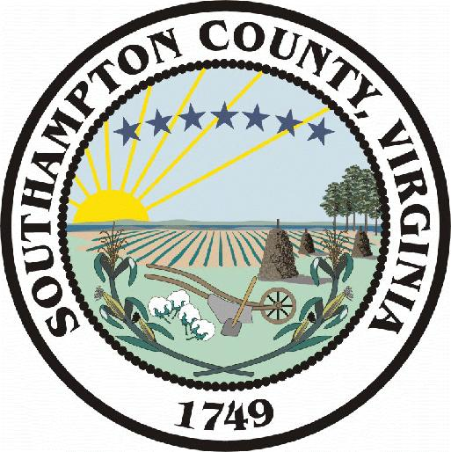
department of community development
planning - building inspections – zoning

Alert: EOP Coronavirus – Inspection Protocols

The Department of Community Development is looking at limiting the type of inspections we perform, for example:

Limited Field Inspections

1. New commercial and residential construction only;

2. Exterior construction to dry-in phase, including;
site work/ E&S/ Stormwater /groundwork
footing/foundation/slab
sheathing/air barrier;

3. Indoor inspections in occupied homes will be re-scheduled for 2 weeks
out if not critical. Inspections indoors that are critical (no heat, water,
electricity, gas) are being handled per the inspector’s best judgement.

3. Other Inspections
Solar panel system installation with exterior disconnect
Temporary power pole
Exterior meter base
Water/sewer replacement
Rough-in and final inspections of vacant, newly constructed buildings
Exterior Electrical Panel replacements
Gas equipment installation and replacement
Performing any type of inspection in an emergency capacity.
Property maintenance inspections limited to emergency damage assessments during normal working hours.
We will accept third party inspections in accordance with our third party inspection policy via email.

Alert: EOP Coronavirus – Process for issuing building / construction related permits

The Department of Community Development will continue to issue building and construction trade permits as well as all environmental permits (Stowmwater and Erosion and Sediment Control). Below is the process options that will be available to you.
Option 1. Preferred option: Submit all construction documents by email to either of the following staff members.
sbaker@franklinva.com, psherman@franklinva.com, and jdrewry@franklinva.com
Option 2. There will be a drop box located at the First Avenue entrance to the building. All plans, applications and all other construction documents may be placed there. Please insure that all the information is in one package to prevent things from coming apart.
This drop box will be checked on a regular basis. Should we need additional information we will contact you. As always, you can contact us directly. Click on the link below for all Community Development staff contact information.
https://www.franklinva.com/government/departments/community-development/
Option 3. Should your plans and construction documents NOT fit into the drop box you can call and make an appointment to leave them with a staff member. Someone will meet you to let you in the lobby facing First Avenue.
You will be asked to keep a safe distance from staff when entering the lobby. You will be asked to sign in with your name, business and contact information. Once it is confirmed that your submittal package is complete you may exit the building.
Payments for permits may be paid by placing a check in the drop box at the First Avenue building entrance or the one in the parking lot. Be sure to indicate on the check the permit address.
Credit and Debit cards are still being accepted by calling the treasurer’s office at 757-562-8540 or 757-562-8519.

