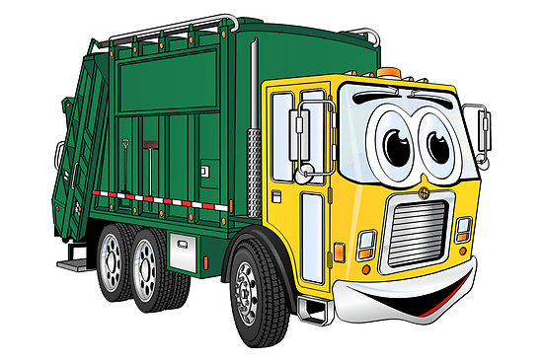
city of franklin
quarterly Amnesty collection Schedule for 2020
First Quarter: February 3, 2020 through February 7, 2020
Second Quarter: April 6, 2020 through April 10, 2020
Third Quarter: August 10, 2020 through August 14, 2020
Fourth Quarter: November 2, 2020 through November 6, 2020
*only on your regular trash day
Our City Council is committed to making our City a clean and inviting place to live. Our hope is that increasing the opportunity of Amnesty Collections for our citizens we can all work together to keep our city clean and beautiful. Thank you for your help with this and if you have any questions concerning these collection schedules please call the public works department at 757-562-8564.
Franklin City manager, Amanda C. Jarratt
* City of Franklin resident owners and tenants only.

