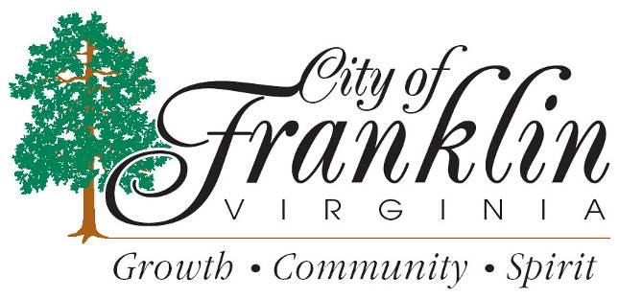

HOLIDAY TRASH PICK UP

City Offices will be closed Monday, October 14, 2019 for Columbus Day.
Monday’s Trash route will be picked up on Tuesday, October 15, 2019 along with Tuesday’s route.

