Construction/ Maintenance Worker | - City of Franklin CMW1
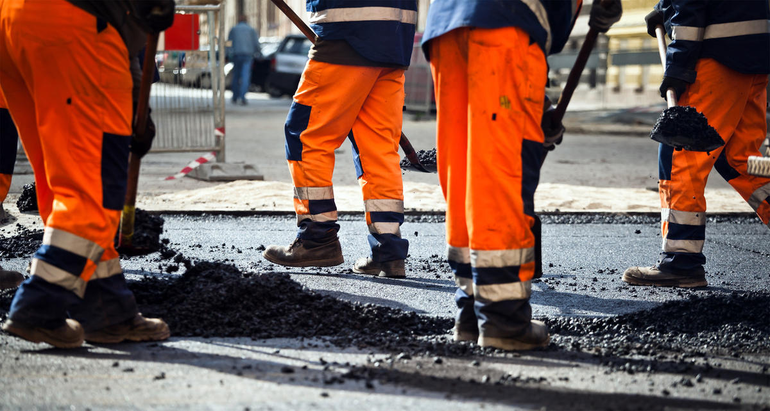  Job Description and Requirements:  Salary DOQ + benefits. Must have High School graduate or equivalent & a Class B CDL preferred. Must have some general understanding about road construction, concrete construction, asphalt installation & drainage construction, have some truck driving experience as well as heavy construction experience operating heavy equipment.  For a full job description and details use the contact information on the right! This job is open until filled! | 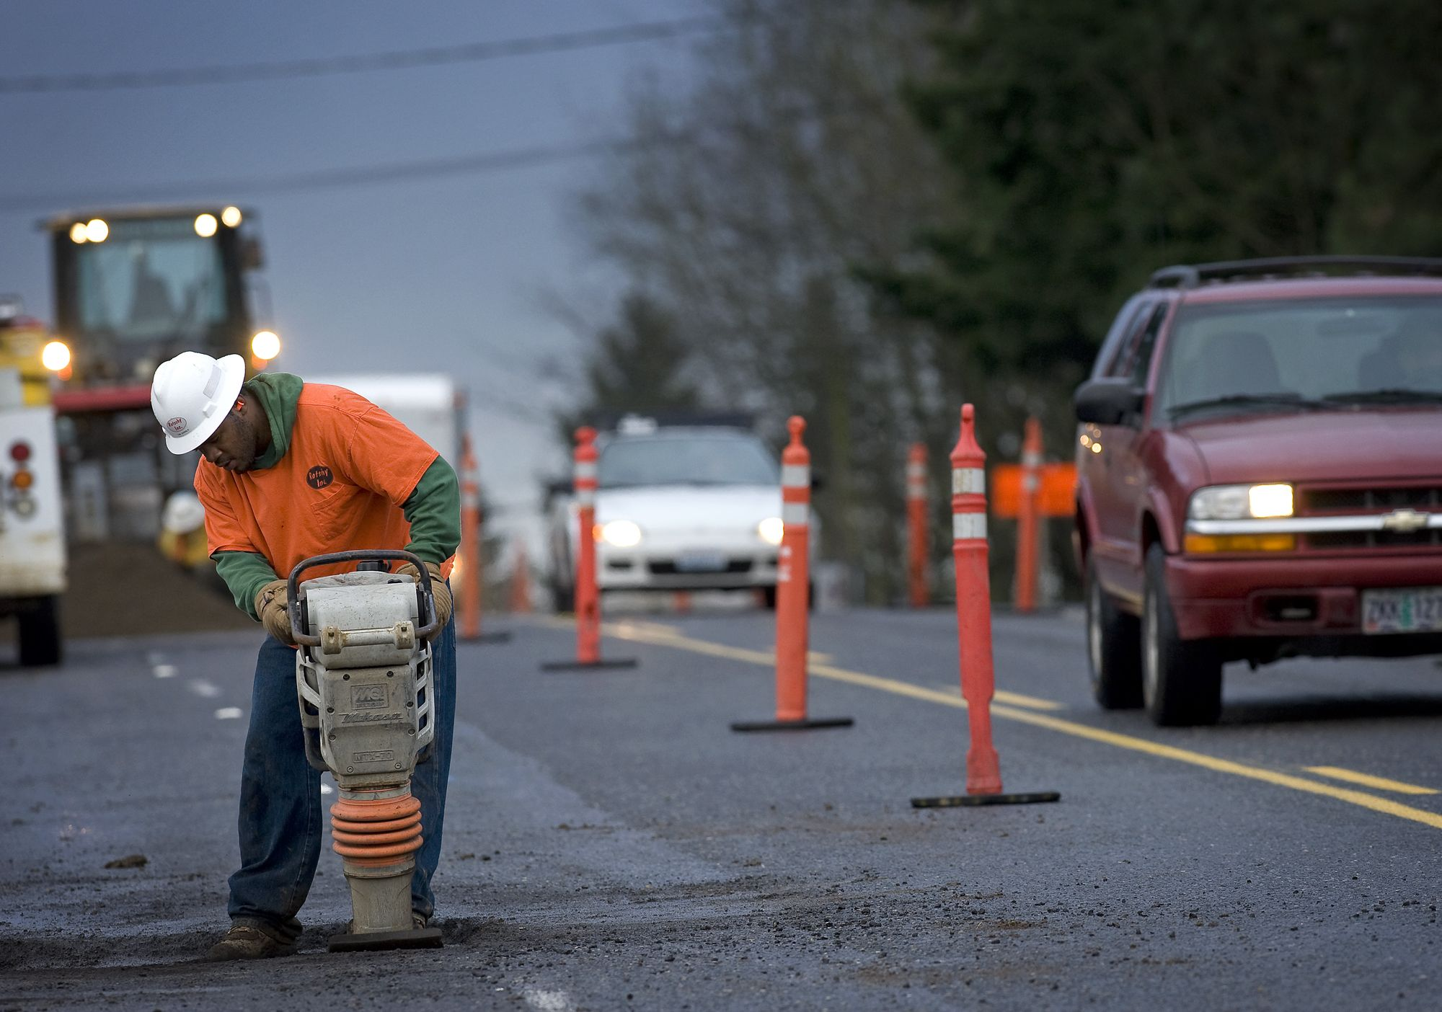  Contact Info  Telephone: (757) 562-8508  Office: 207 West Second Avenue Franklin, VA 23851
