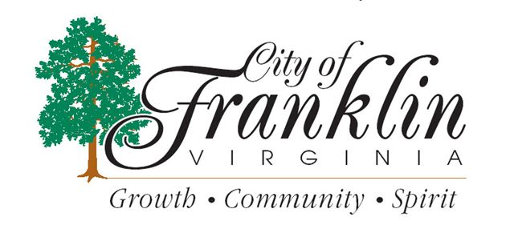
CITY CLIPS
February 2018

www.franklinva.com
IMPORTANT DATES TO REMEMBER:

Recycling Dates – Feb. 8th, 9th, 22nd, 23rd
(All meetings below are held in Council Chambers at City Hall
City Council Meetings – Feb. 12th & 26th
School Board Meetings – Feb. 15th
Planning Commission Meeting – Feb. 22nd

************************************************************************

Our offices will be closed Monday 2/19 in observance of George Washington Day … trash will be picked up as regularly scheduled.

************************************************************************************

The Wampler-Eanes Appraisal Group, Ltd has started the 2018 General Reassessment. Members of the reassessment team have started visiting properties to take exterior pictures and measurements of your property in order to determine the fair market value. If you are not at home, a yellow card will be left on your front door to let you know he/she has been at your property. If the assessor needs further information he will leave his/her phone number to get in touch with them. The Assessors have photo I.D.’s and will have magnetic “City Reassessment” signs on their vehicles.
The field assessments are expected to be completed in February 2018 and the notices of the proposed change in the assessed value will be mailed to property owners in March 2018. The notices will give the details on the method of appealing the proposed assessed value.
If residents have any questions, please call Brenda Rickman, Commissioner of the Revenue at 562-8548 or Betty Tarkington 562-4870.

Message from the Treasurer’s Office.

Real Estate and Personal Property Tax bills for 2017 have been sent out. 1st half of RE2017 and PP2017 taxes are due date is December 05, 2017. To void penalty of 10% please pay on or before the due date.

If you have not received your tax bill, please call 757-562-8536 or 757-562-8540 to inquire, or stop by the Treasurer’s office. Not receiving your bill does not exempt from being charged penalty and interest if not paid by the Tax due date.

Please notify the Treasurer’s office if your taxes have been previously paid by your Mortgage Company and you have recently paid off your mortgage, so that we may mail you your Tax bill.

The Treasurer’s office continues to sell EZ Passes. For more information, please stop by the Treasurer’s office or call 757-562-8540 or 757-562-8536

City Business License Applications have been mailed and are due March 1, 2018 with payment. If you have any questions, please call Marcy Wiggins at 562-8547 in the Commissioner of the Revenue’s Office.
2017 Virginia State Income Tax Forms will not be mailed to individual taxpayers. The Commissioner of the Revenue’s Office has a limited number of forms and instruction booklets for distribution. Forms and instructions are available on demand through the following options:
- Download, view or print forms directly from the Department of Taxation website at www.tax.virginia.gov.
- Order forms online through the Department’s website or call (804) 367-8031.
If you fill out your tax return by hand, you can avoid processing delays by printing your information so it can be easily read. Please use black ink and not pencil.

Effective January 1, 2017 – local Commissioner of the Revenue Offices will no longer be able to process accelerated refunds for taxpayers. We can accept your return and audit for mistakes or omissions but we will be mailing them directly to Richmond for processing. This is all due to identity theft and refund fraud.
HOW LONG WILL IT TAKE TO GET MY REFUND?
- Up to 4 weeks for e-filed returns
- Up to 8 weeks for paper returns
- Up to 3 additional weeks if sent by certified mail

For FCPS SPORTS SCHEDULES, please visit:http://www.tririversdistrictva.org/g5-bin/client.cgi?G5genie=302&school_id=4

