FIRE & RESCUE

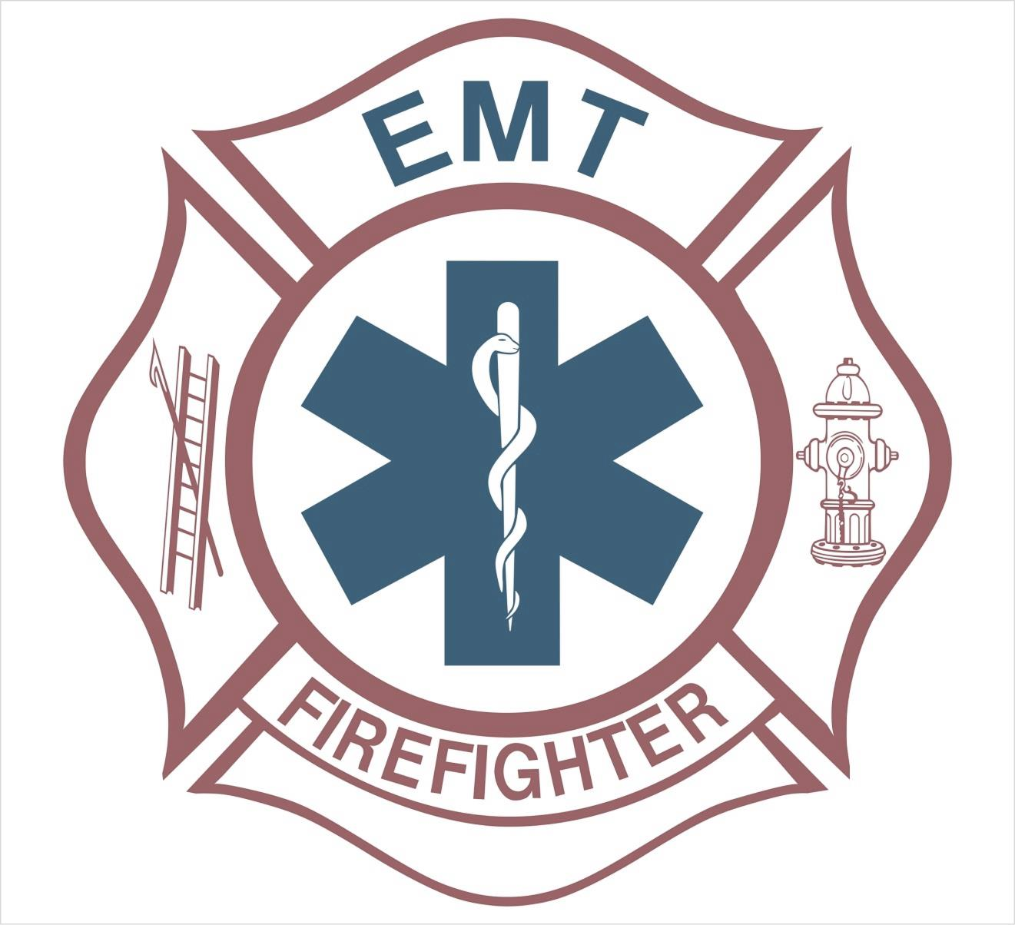

FIREFIGHTER/MEDIC – Salary DOQ + excellent fringe benefits such as tuition reimbursement & career development incentives. Min. requirements include a HS Grad. or equivalent, valid State of VA Driver’s License, copy of your DMV record with a zero or plus points balance. Preferred requirements: Firefighter II, EMT –B, EMT- A, EMT-I or EMT-P. Must have the ability to pass a written test, physical agility test, psychological test and thorough background investigation

For a full job description/application contact the Personnel Department, 207 W. 2nd Avenue - Franklin, VA 23851 (757) 562-8508. OPEN TILL FILLED. EOE/M/F/H

MULTIPLE POSITIONS AVAILABLE

