CITY CLIPS
July 2017

www.franklinva.com
IMPORTANT DATES TO REMEMBER:

Recycling Dates – July 13th, 14th, 27th, 28th
(All meetings below are held in Council Chambers at City Hall
City Council Meetings – July10th & 24th
School Board Meetings – July 20th
Planning Commission Meeting – July 27th

Trash picked up 3rd and 4th but offices closed for Independence Day! No bulk items pick up for 7/5/17.

***********************************************************************************
Along with all their other wonderful events, MLK has a FREE exercise class every Monday from 6:30 to 7:30 p.m. For further information, contact the King Center @ 757-562-2475.
************************************************************************************

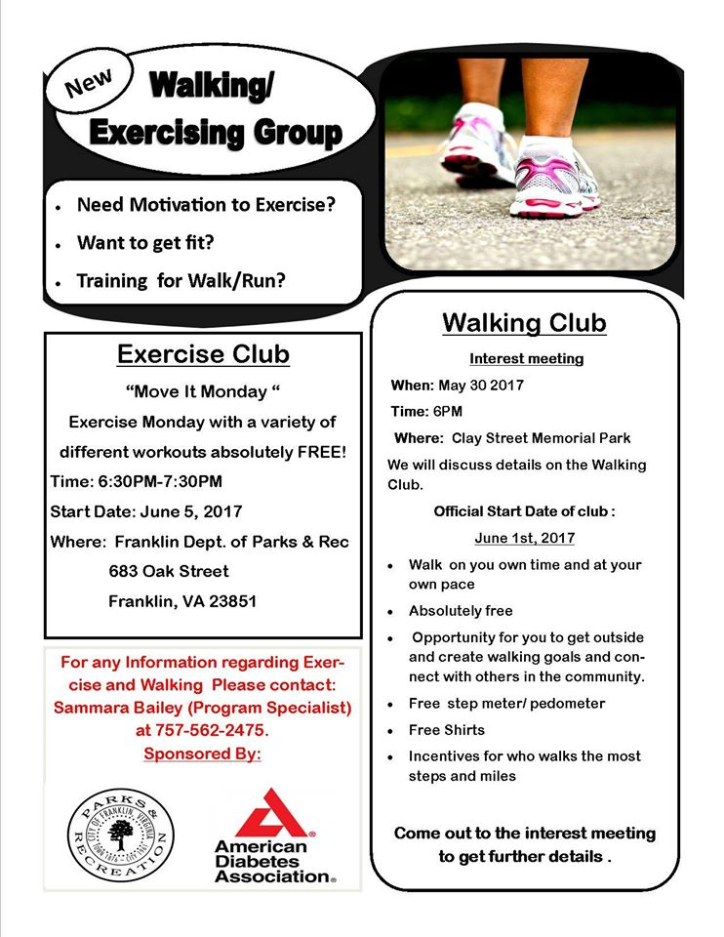

For FCPS SPORTS SCHEDULES, please visit:http://www.tririversdistrictva.org/g5-bin/client.cgi?G5genie=302&school_id=4

