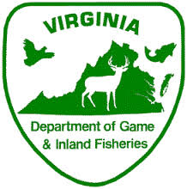

Virginia Boating Safety
Education Course
Boat Virginia!

Where: Franklin Fire and Rescue
When: February 25, 2017 9 am to 5 pm
Who: Open to the public
What: Boat Virginia course FREE to all who attend. This course meets requirements for boating safety education in Virginia.
Contact Tim Dunn (757) 377-6508

All students must register online at www.dgif.virginia.gov

