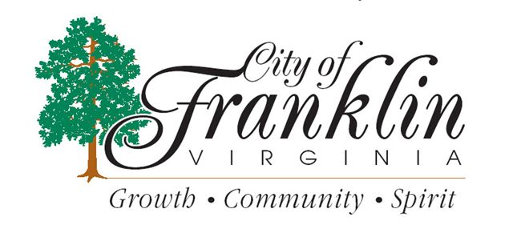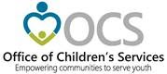
PUBLIC MEETINGS

Community Policy & Management Team (CPMT)
BOARD MEETINGS

The mission of the CPMT is to provide leadership in the development of new concepts and approaches in the provision of services to at-risk youth and families residing in the City of Franklin. The primary focus of the CPMT is to lead the way to effective and efficient services for the youth and their families, when the youth is experiencing emotional and/or behavioral problems, or is at risk of or in need of an out of home placement.
CPMT meets on a monthly basis to discuss policy issues relating to service provision, funding and expenditures, and any issues relating to the functionality of the CSA program. Meetings are typically on the 2nd Tuesday of each month, and held at:
Franklin Dept. of Social Services
306 N. Main Street
Franklin, VA 23851

The meeting calendar for 2022 is as follows:
January 11, 2022 at 2pm July 12, 2022 at 2pm
February 8, 2022 at 2pm August 9, 2022 at 2pm
March 8, 2022 at 2pm September 13, 2022 at 2pm
April 12, 2022 at 2pm October 11, 2022 at 2pm
May 10, 2022 at 2pm November 10, 2022 at 2pm
June 14, 2022 at 2pm. December 13, 2022 at 2pm

Meetings are subject to change, depending on availability of team members. If you are planning on attending a CPMT meeting, please call CSA Coordinator, Sarah Allen, on 757-562-8602 the day prior to the meeting to verify that the meeting will not be rescheduled.

